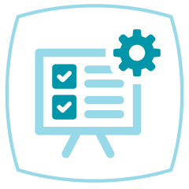
IIS Leadership Workshop Action Plan
Purpose: We encourage you to develop an action plan to continue the momentum gained from the IIS Leadership Workshop and apply the ideas, insights, resources, and tools discussed once you are back in your office. Transitioning the energy and knowledge gained through your interactions with peers and faculty into concrete, actionable steps will significantly contribute to your development as an IIS leader.
Directions:
1. Utilizing the template below, develop an action plan for the domains/topics that resonate with you during the IIS Leadership Workshop. A couple of examples are provided, followed by a list of potential focus areas in “My IIS Leadership Action Plan” to get you started. Use the empty rows within the template to include additional areas that will help you maintain the momentum gained from the workshop. Discuss your ideas within your table teams for further input to finalize your written plan.
2. By the end of the workshop, choose at least one leadership buddy, exchange contact information, and set a date to follow up with each other regarding your progress.

Examples:
Domain/  Topic | Goals | Tasks/  Activities | Developing Skills | Resources/  Tools | What does success look like?
Create the Vision & Strategy | Define a 3-year roadmap aligned with DOH/program strategy | Review the DOH/Program Strategic Roadmap to identify opportunities/gaps | Strategic planning and facilitation | Direct, collaborative, and communicative relationship building with DOH/programs | Roadmap finalized and approved
Build a Strong Team | Ensure 5 key IIS roles filled and their responsibilities are well documented and communicated | Conduct a skills gap analysis of current IIS staff | Staff assessment and organizational planning | IIS Core Competency Model, PHII Role Descriptions, Staff Roles Matrix, PHII training courses | All 5 key positions filled

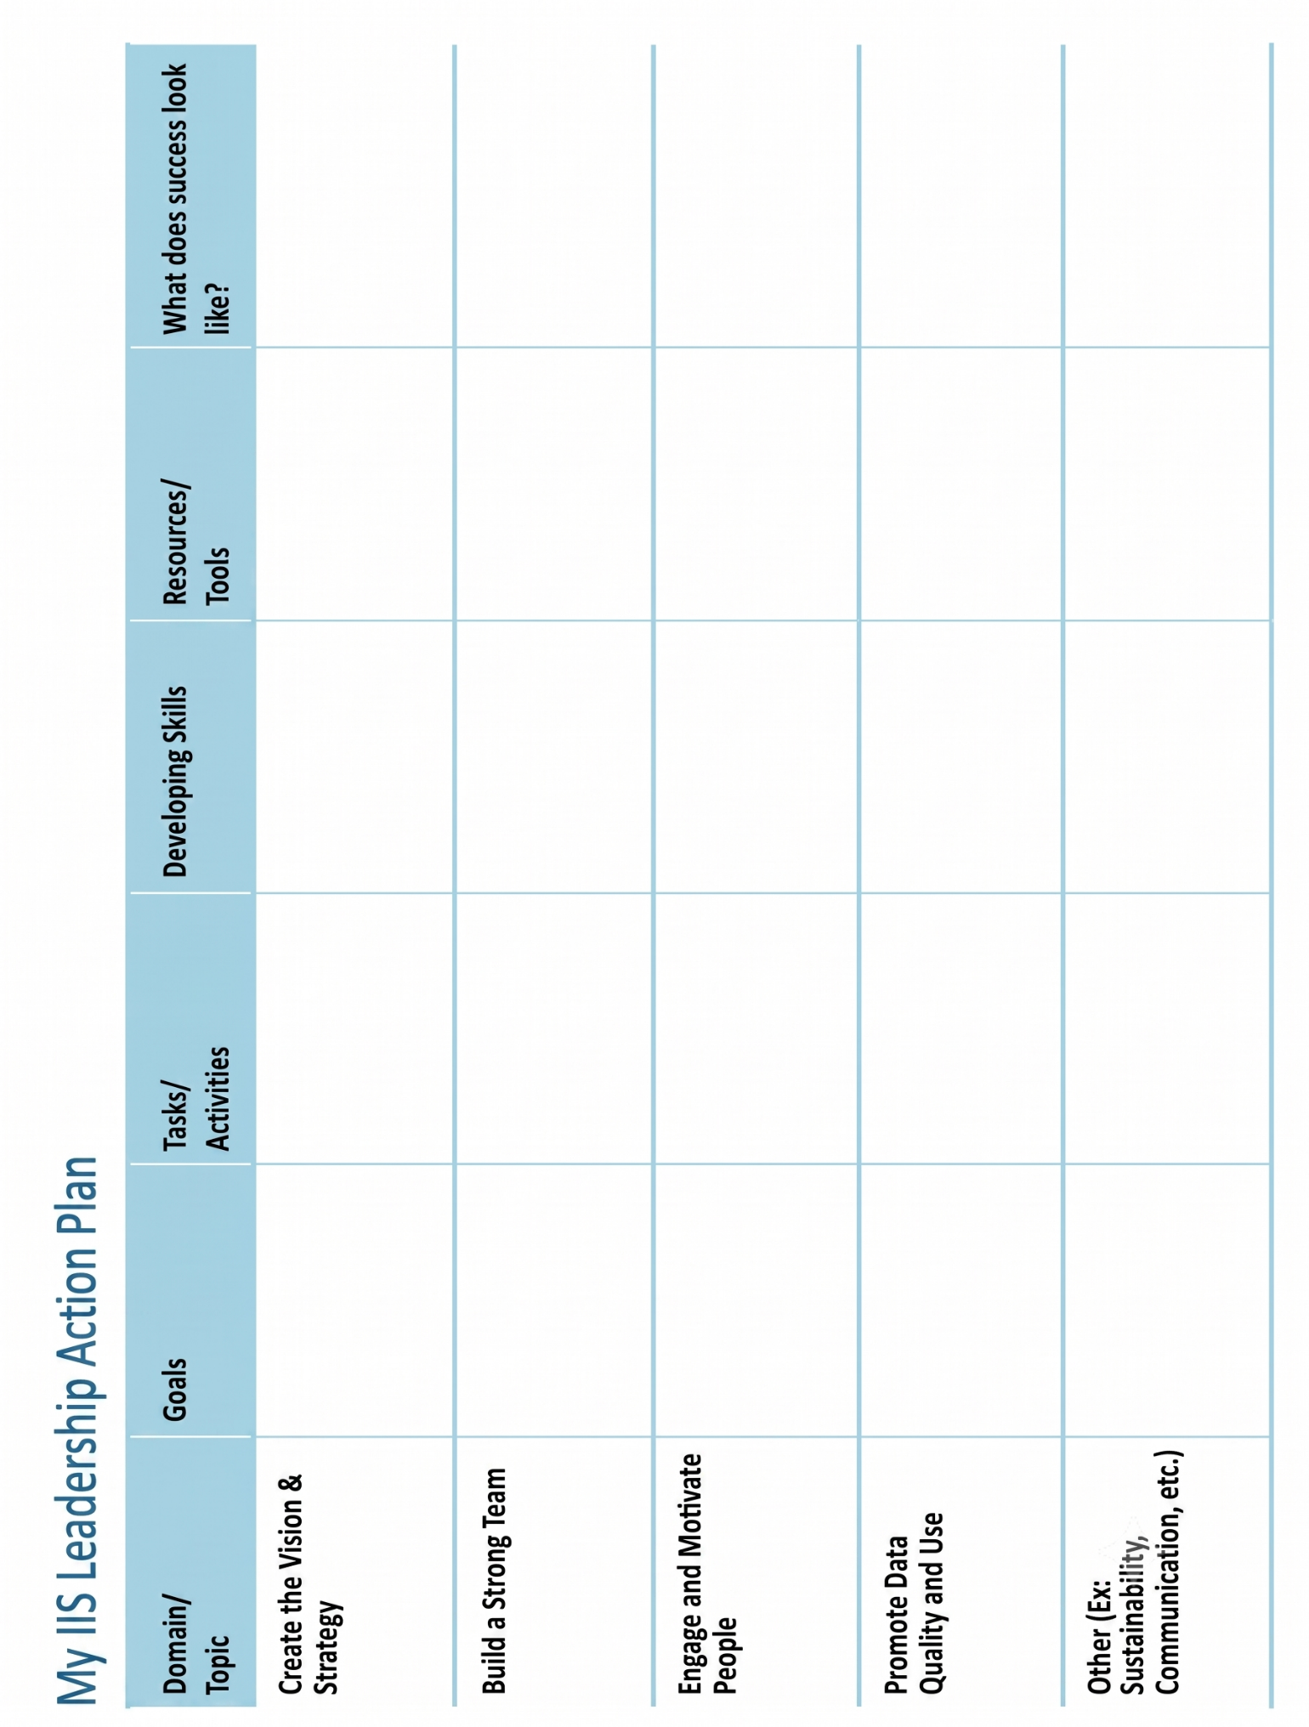
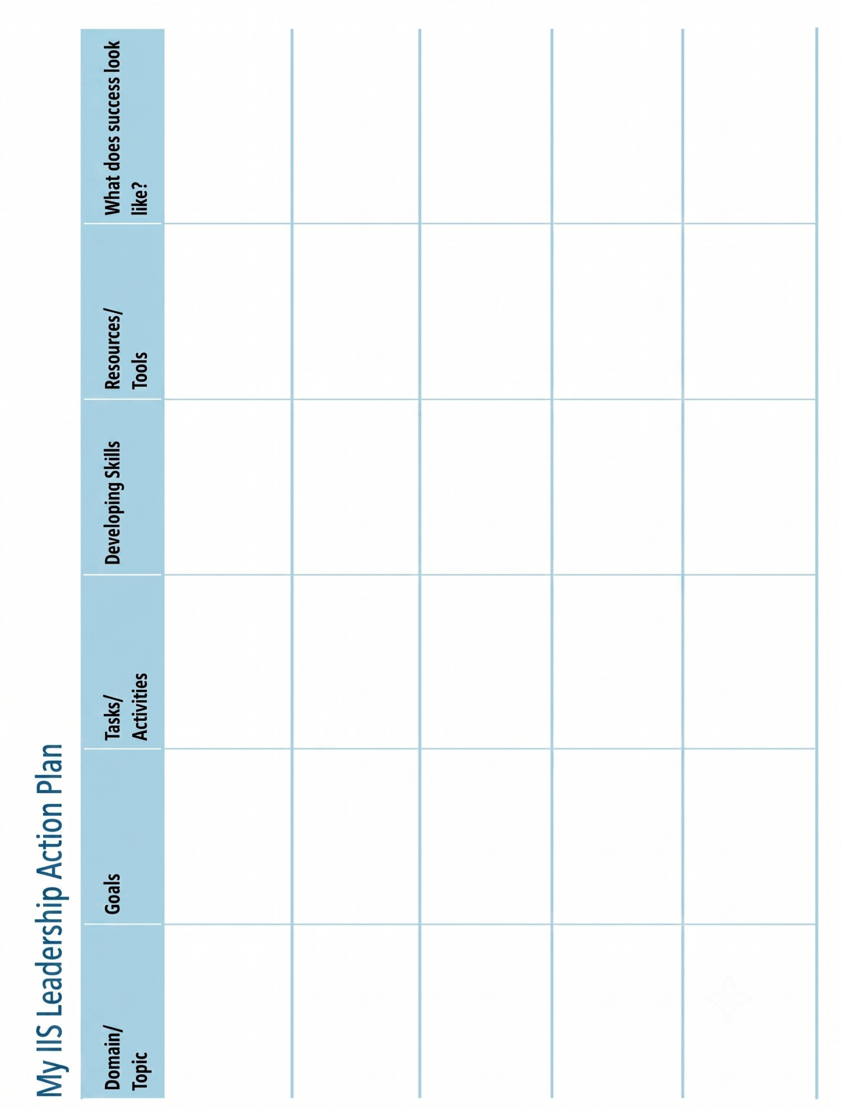
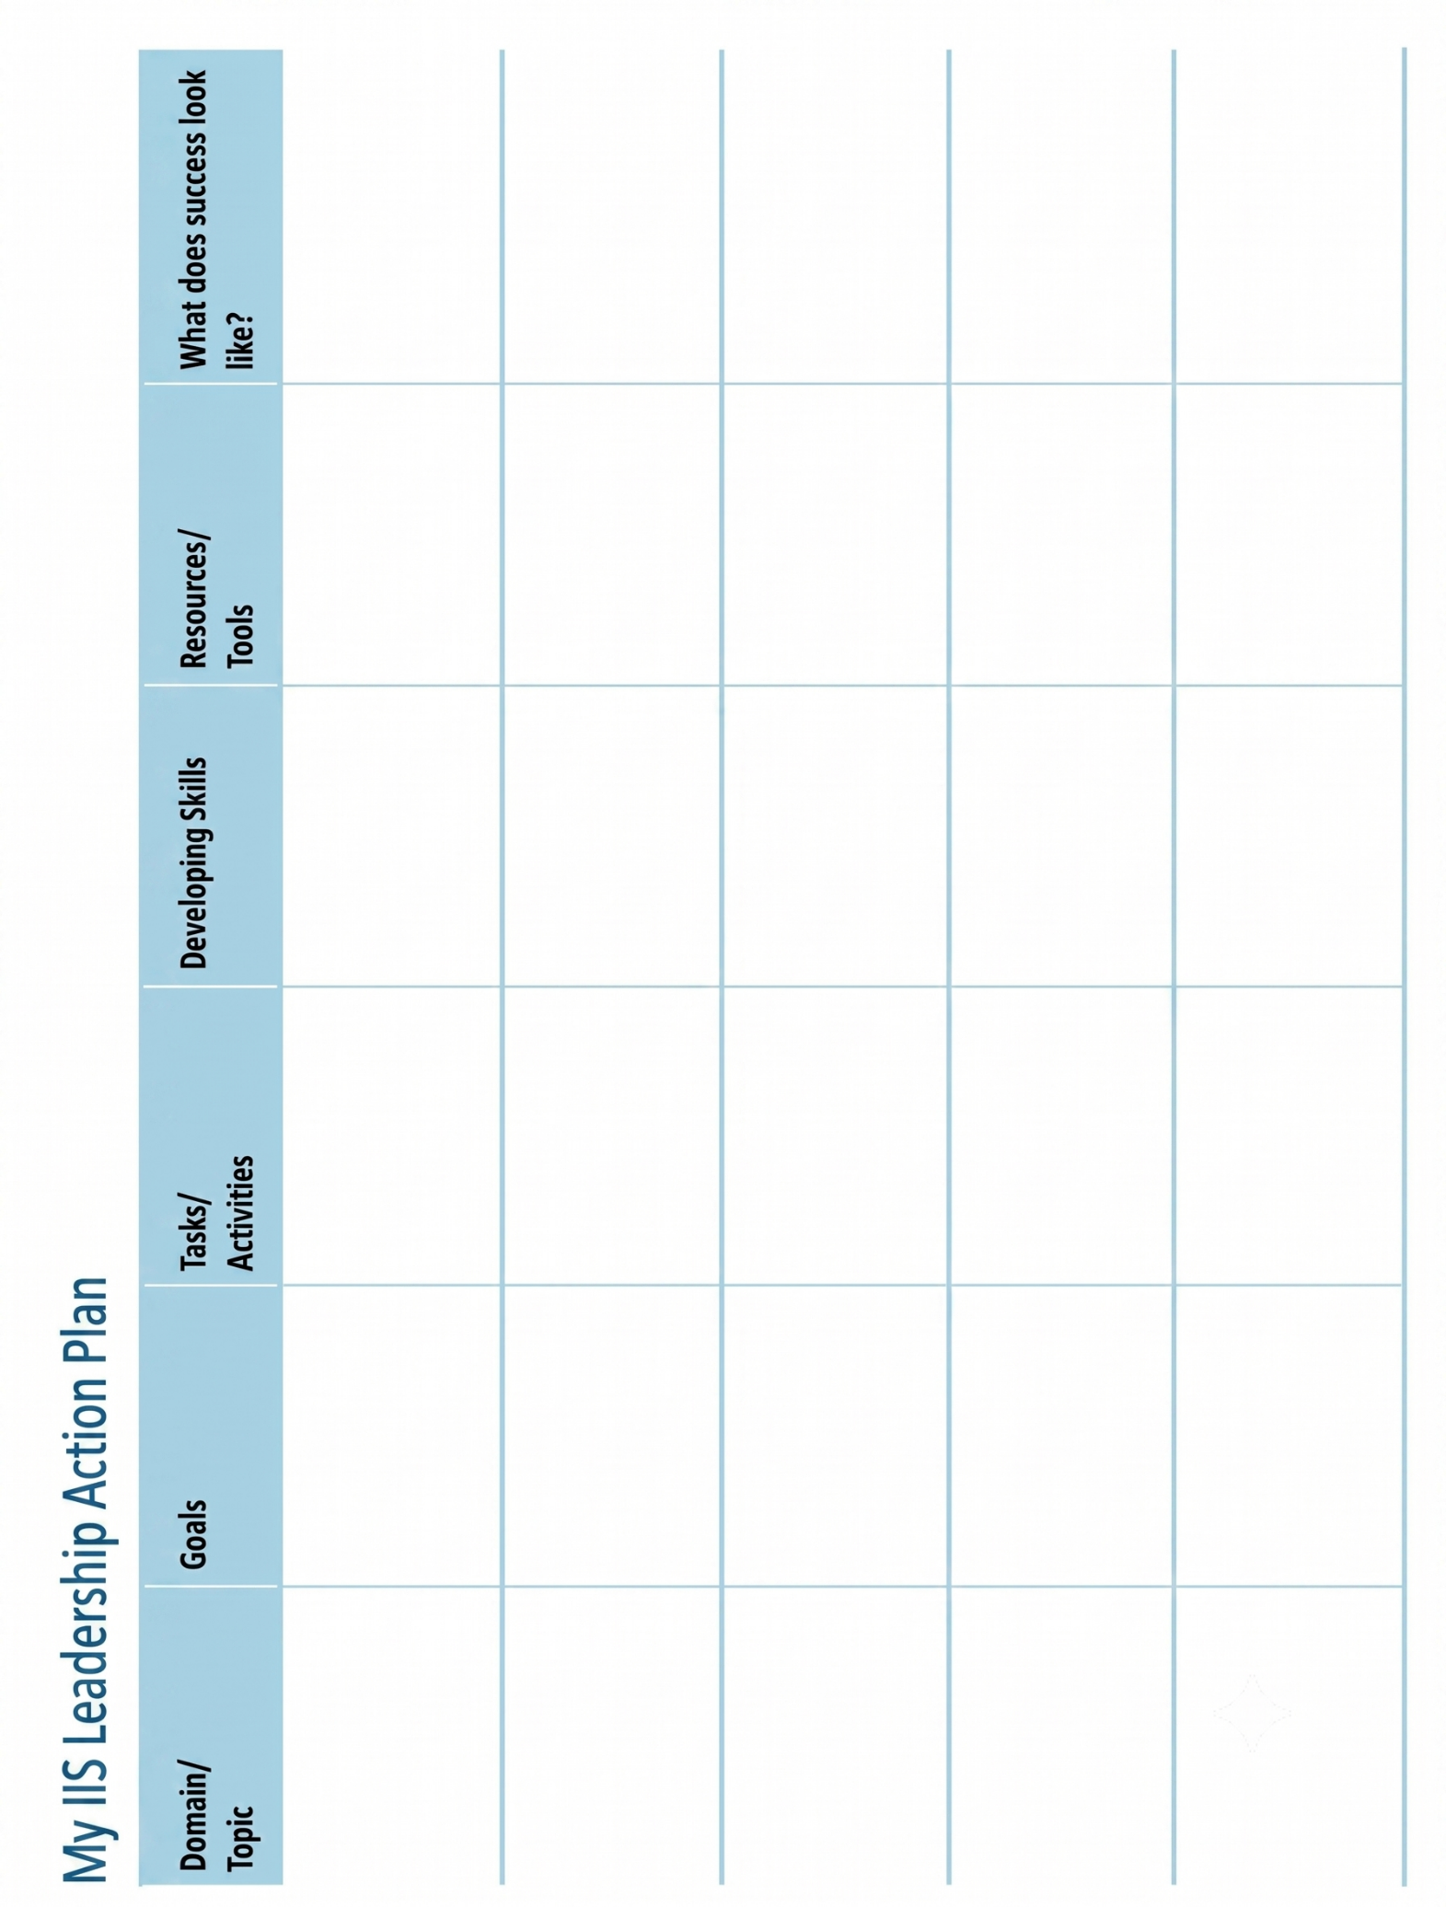

Leadership Buddies
First Name | Last Name | Organization | Phone Number | Email Address | Follow-up Date

