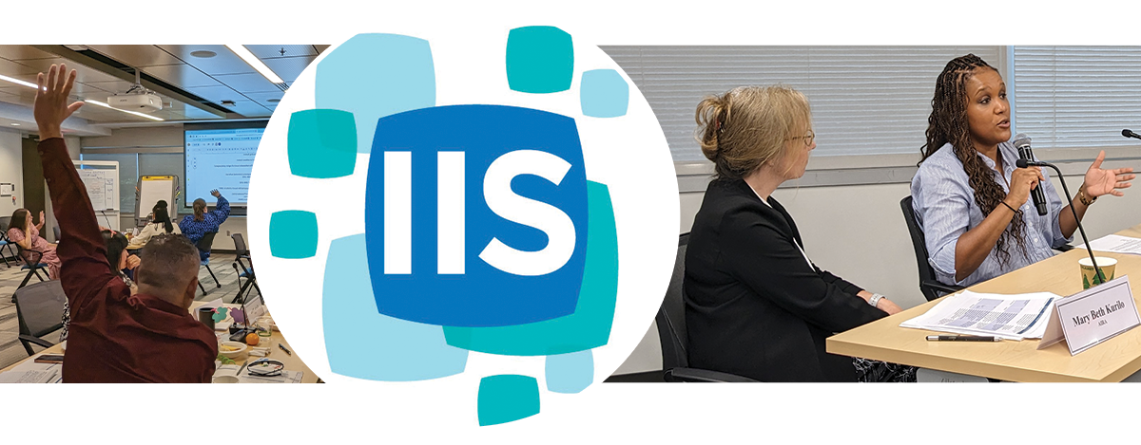
Immunization Information System (IIS) Leadership Workshop
June 4-6, 2024
Public Health Informatics Institute
Decatur, GA

Table of Contents

Table of Contents 1
Introduction 2
Objectives and Goals 2
Instructions 2
Agenda 3
Faculty, Panelists and Staff 6
Participant List 14
Day 1 – Tuesday, June 4, 2024 15
Welcome and Workshop Overview 15
Role of an IIS Leader 15
CDC and the IIS Community 17
Networking Event: IIS Trivia 19
Data Quality 19
AIRA Overview 22
Communication 27
World Cafe 31
Day 1 Wrap-Up 31
Day 2 – Wednesday, June 5, 2024 32
Day 2 Welcome and Recap 32
Lightning Round 32
Coffee Klatch 33
Effective IIS Data Use 33
IIS Functional Standards 35
The “IIS View” 36
Networking Event: Bingo 37
PHII Overview 37
Change Management, Project Management, and the Systems Development Life Cycle 38
Day 2 Wrap-Up 41
Day 3 – Thursday, June 6, 2024 42
Day 3 Welcome and Recap 42
Laws, Policies and Procedures 42
Networking Event: CDC SME Session 45
IIS Budget and Sustainability 45
IIS Assessment, Planning and Prioritization 47
Vision for IIS from CDC 49
IIS Strategic Vision Panel 50
Day 3 Wrap-Up 50
Appendix A: Common IIS Acronyms 51
Appendix B: Project Management Framework 54
Appendix C: IIS Functional Model 55

Introduction
Welcome to the 2024 IIS Leadership Workshop! As a leader in your immunization program, you are in a position to advance and leverage your IIS to support federal, state, local and territorial immunization goals. During this three-day learning experience, you will increase your competencies and confidence in facing the challenges of IIS and leadership positions.
Faculty from the Centers for Disease Control and Prevention’s (CDC) Informatics and Data Analytics Branch (IDAB), the American Immunization Registry Association (AIRA), and the Public Health Informatics Institute (PHII) will lead you through a series of modules and activities to bolster your technical, policy and operational knowledge of IIS. You will be challenged to apply this learning to your program and identify priorities for action.

Objectives and Goals
The overall purpose of this workshop is to build leadership capabilities to coordinate and leverage the interrelated components of IIS—people, policies, processes and technology—in support of immunization program goals.
This workshop aims to:
- Present information in a manner that enables participants to be knowledgeable of current and emerging topics that impact the IIS community
- Provide useful information and links to resources
- Clearly outline the roles and responsibilities of an IIS leader
- Help foster networking and collaboration opportunities with participants and faculty
The event will do so by:
- Sharing IIS information from various perspectives
- Encouraging a space for open and candid dialogue between IIS community faculty and participants
- Clarifying the core responsibilities of an IIS leader
- Identifying strategies for prioritizing tasks outside of the traditional job scope of an IIS leader

Instructions
This workbook is designed to give you everything you need to follow along during the workshop, take notes, participate in activities and pick up where you left off when you return to work after the workshop.

Agenda
Day 1: Tuesday, June 4, 2024
8:30 AM - 9:00 AM | Breakfast (provided by PHII)
9:00 AM - 9:30 AM | Welcome and Workshop Overview
9:30 AM - 10:15 AM | Icebreaker
10:15 AM - 11:00 AM | Role of an IIS Leader
11:00 AM - 11:10 AM | Break
11:10 AM - 11:55 AM | CDC and the IIS Community
11:55 AM - 12:45 PM | Lunch
12:45 PM - 1:05 PM | Networking Event: IIS Trivia
1:05 PM - 2:15 PM | Data Quality
2:15 PM - 2:45 PM | AIRA Overview
2:45 PM - 2:55 PM | Break
2:55 PM - 3:40 PM | Communication
3:40 PM - 4:20 PM | World Café
4:20 PM - 4:35 PM | Leadership Action Plan
4:35 PM - 4:50 PM | Day 1 Wrap-up
Eastern Daylight Time
Join your colleagues and workshop facilitators at BOHO115 for an AIRA-hosted dinner at 6:00 PM! Meet in the Hampton Inn and Suites lobby at 5:45 PM to walk with others.

Day 2: Wednesday, June 5, 2024
8:30 AM - 9:00 AM | Breakfast (provided by PHII)
9:00 AM - 9:20 AM | Day 2 Welcome and Recap
9:20 AM - 10:10 AM | Lightning Round
10:10 AM - 10:20 AM | Group Photo
10:20 AM - 10:30 AM | Coffee Klatch
10:30 AM - 10:40 AM | Break
10:40 AM - 11:25 AM | Effective IIS Data Use
11:25 AM - 12:00 PM | IIS Functional Standards
12:00 PM - 12:50 PM | Lunch
12:50 PM - 1:50 PM | The “IIS View”
1:50 PM - 2:20 PM | Networking Event: IIS Bingo
2:20 PM - 2:50 PM | PHII Overview
2:50 PM - 3:00 PM | Break
3:00 PM - 3:45 PM | Change Management, Project Management and the System Development Life Cycle
3:45 PM - 4:00 PM | Leadership Action Plan
4:00 PM - 4:30 PM | Day 2 Wrap-up
Eastern Daylight Time

Join your colleagues and other workshop participants for a Ping Pong Tournament following the day’s activities. Prizes will be given to the champion and runner-up teams!

Day 3: Thursday, June 6, 2024
Participants should check out of the hotel in the morning and bring their luggage to the last workshop day. A shuttle to the airport will be provided.
8:30 AM - 9:00 AM | Breakfast (provided by PHII)
9:00 AM - 9:10 AM | Day 3 Welcome and Recap
9:10 AM - 9:55 AM | Laws, Policies, and Procedures
9:55 AM - 10:25 AM | Networking Event: CDC SME Session
10:25 AM - 10:40 AM | Break
10:40 AM - 11:25 PM | IIS Budget and Sustainability
11:25 PM - 12:05 PM | Assessment, Planning and Prioritization
12:05 PM - 12:20 PM | Break
12:20 PM - 12:45 PM | Vision for IIS from CDC
12:45 PM - 1:35 PM | Lunch
1:35 PM - 2:35 PM | IIS Strategic Vision Panel
2:35 PM - 2:50 PM | Leadership Action Plan
2:50 PM - 3:20 PM | Workshop Wrap-up
Eastern Daylight Time

Faculty, Panelists and Staff
Workshop Faculty
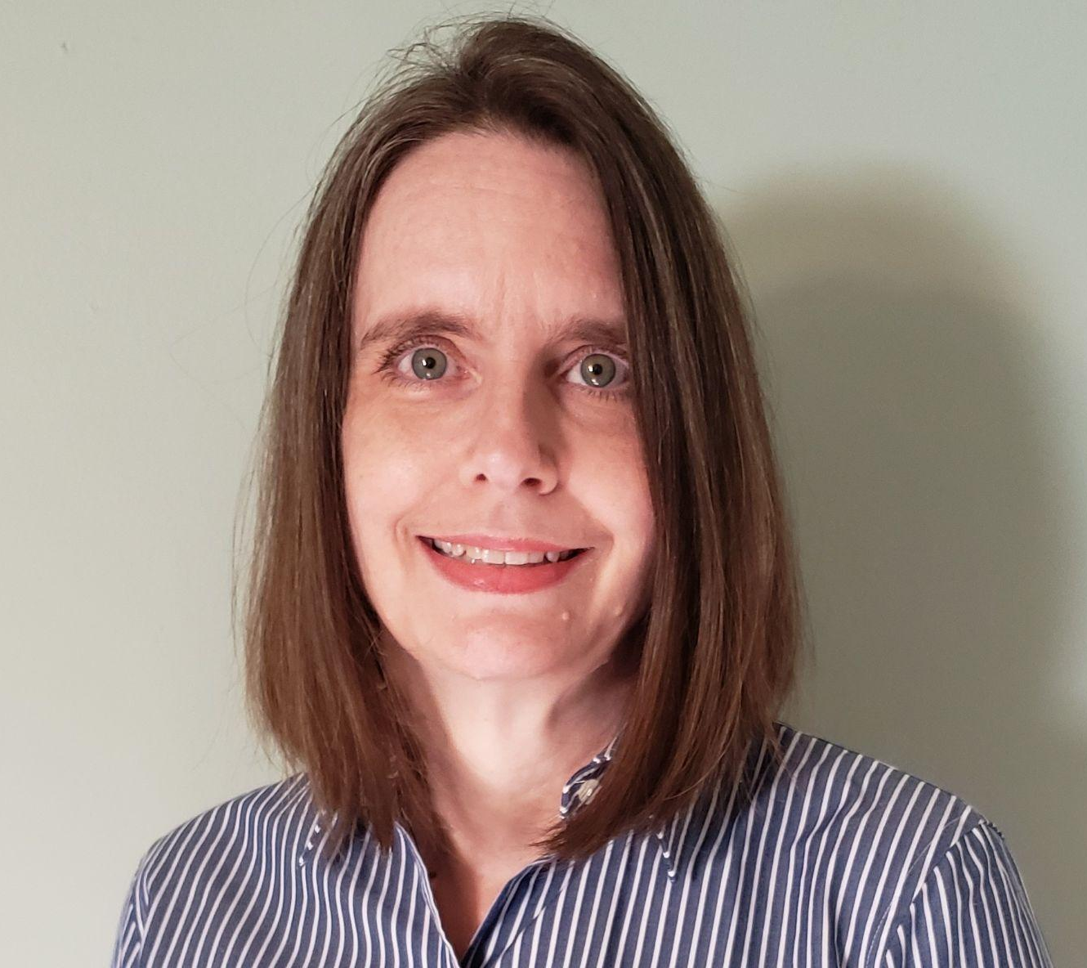  Beth Cox | Outreach and Technical Assistance Team Lead, CDC/IDAB  Beth Cox is the Outreach and Technical Assistance Team Lead in CDC’s Informatics and Data Analytics Branch (IDAB), which assists vaccination program awardees with their IIS implementations and utilization to support jurisdictional immunization programs and initiatives. She previously served in Florida’s Immunization Program as the Vaccines for Children (VFC) Manager, the Field Operations Manager and the IIS Training Consultant. Prior to her job in Florida, she worked in the EXPO Division of Home Depot as a Human Resources Manager and a Systems Instructional Designer. Beth earned a B.A. from Davidson College in NC, and a Masters in Human Resources Development from Georgia State University.  (E): nhy7@cdc.gov  (P): 404-718-5698
  Jan Hicks-Thomson | Outreach and Technical Assistance Team Lead, CDC/IDAB  Jan has been with the CDC for 7 ½ years and is currently a team lead for the Outreach and Assistance Team in CDC’s Informatics and Data Analytics Branch. She was previously an IIS subject matter expert for the Branch and supported multiple states IIS and CDC Cooperative Agreement efforts. She has led CDC work with federal agencies, IIS Functional Standards, provider IIS participation, IIS sustainability, and Cooperative Agreement components. Prior to coming to CDC, she held positions within state and local public health agencies and was instrumental in integrating provider and program business practices into the IIS. She earned her MSW and MPA from Eastern Washington University and her bachelor’s degree from Montana State University.  (E): hbv8@cdc.gov  (P): 404-718-1555
  Mary Beth Kurilo | Senior Director of Health Informatics, AIRA  Mary Beth Kurilo currently fulfills two roles, working as a Public Health Consultant and Trainer with PHII, and as a Senior Director of Health Informatics at AIRA. Prior to 2014, she worked as the Director of the Oregon ALERT IIS for eight years. She has been immersed in the IIS community for over 20 years and has served as a past AIRA President and as a Co-Chair or Lead for AIRA’s Education Steering Committee, Standards and Interoperability Steering Committee, and Executive Committee. Mary Beth holds master’s degrees in Public Health and Social Work from the University of Washington.  (E): mbkurilo@gmail.com  (P): 503-407-6205
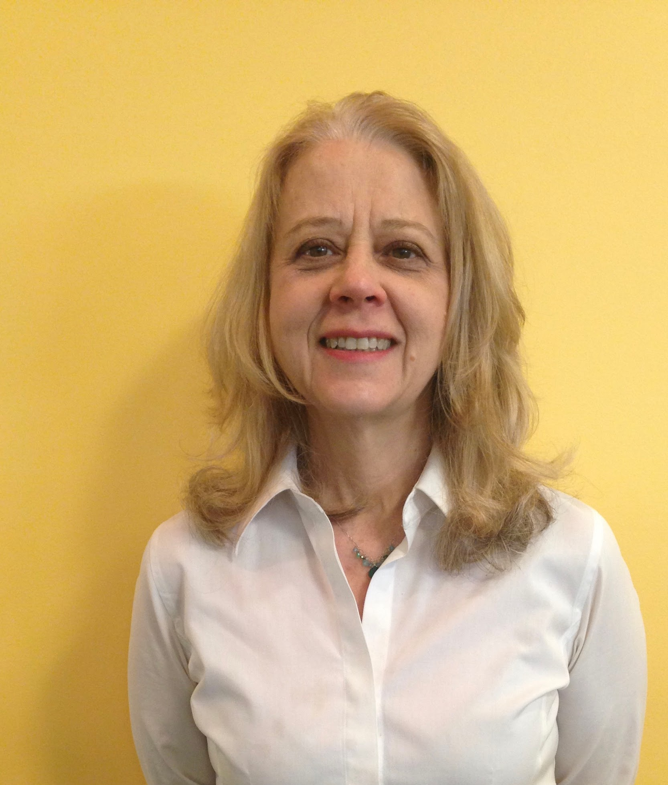  Amy Metroka | Former Director, Citywide Immunization Registry, NYC Dept of Health & Mental Hygiene  Amy Metroka has been in the IIS world since the early 1990s, when IIS were mostly in the planning stages. She was fortunate to have been one of the pioneers of IIS development and the formation of AIRA. Amy served as AIRA president twice, and was a long-time member of AIRA’s IIS Measurement for Assessment and Certification Advisory Workgroup (MACAW) and Modeling of Immunization Registry Operations Workgroup (MIROW) Steering Committee. She started her career as a social work administrator and moved into public health in the 1990s when the Robert Wood Johnson Foundation awarded a planning grant to NYC to explore the idea of developing an IIS. During this time, she got an MPH and a DrPH while working full-time as NYC’s IIS manager. She retired from the NYC Department of Health & Mental Hygiene in January 2022 and is now happy to be working as a part-time consultant for PHII.  (E): ametroka1@gmail.com  (P): 917-575-0020
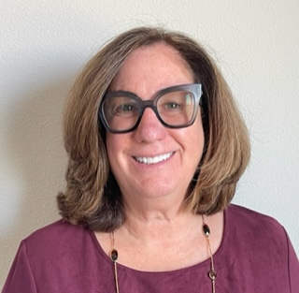  Marcey Propp | Immunization Domain Lead / Sr. Project Manager, HLN Consulting  Marcey Propp brings vast management consulting expertise to support State and Federal public health agencies in strategic planning and improving productivity and efficiency. Marcey provides technical assistance to jurisdictions across the country and applies industry-standard project and change management methodologies and tools to operationalize, optimize, and modernize public health information systems. Marcey guides the delivery of proven and practical solutions in areas related to health, information exchange planning and execution, data migration and validation, requirements collection, testing, process re-engineering, and training. Marcey holds a bachelor’s degree from Rutgers University, a Master of Business Administration from Northeastern University, and she is an active member of AIRA and a Certified Professional in Health Information & Management Systems through HIMSS.  (E): mepropp@hln.com  (P): 856-266-3175
Workshop Panelists
  Kathryn K. Cheek, MD, FAAP | Pediatrician  Dr. Kathryn K. Cheek has been dedicated to the private practice of Pediatrics in Columbus, Georgia, for the past 37 years. Dr. Cheek completed her undergraduate education at the University of North Carolina and earned a Master of Health Education from the Medical College of Georgia at Augusta University. She received her Doctor of Medicine from the same institution and completed her postgraduate training in pediatric residency at Emory University's affiliated hospitals, where she served as Chief Resident in Pediatrics from 1985 to 1986.  Dr. Cheek is a past president of the Georgia Chapter of the American Academy of Pediatrics (GaAAP) and a past chairperson of the Pediatric Healthcare Improvement Coalition of Georgia (PHIC). She has been a member of the Georgia Composite Medical Board since 2021. She has served as a board member of the Georgia Department of Public Health since 2011. She serves on the executive committee nationally on the Council of Clinical Information Technology (COCIT) for the American Academy of Pediatrics.
Rebecca Coyle | Executive Director, AIRA  Rebecca Coyle is the Executive Director of the American Immunization Registry Association (AIRA), where she oversees the development and promotion of tools and best practices to support the implementation of immunization information systems as an essential tool in preventing and controlling vaccine-preventable diseases. Ms. Coyle has a master’s degree in education with an emphasis in public health.  Rebecca began her work in the immunization community in 2002 as the School & Childcare Coordinator for the Idaho Immunization Program. She worked in the Minnesota Department of Health as a CDC Public Health Advisor before returning to Idaho as the Immunization Program Manager. Ms. Coyle joined AIRA in 2010 as the Executive Director.
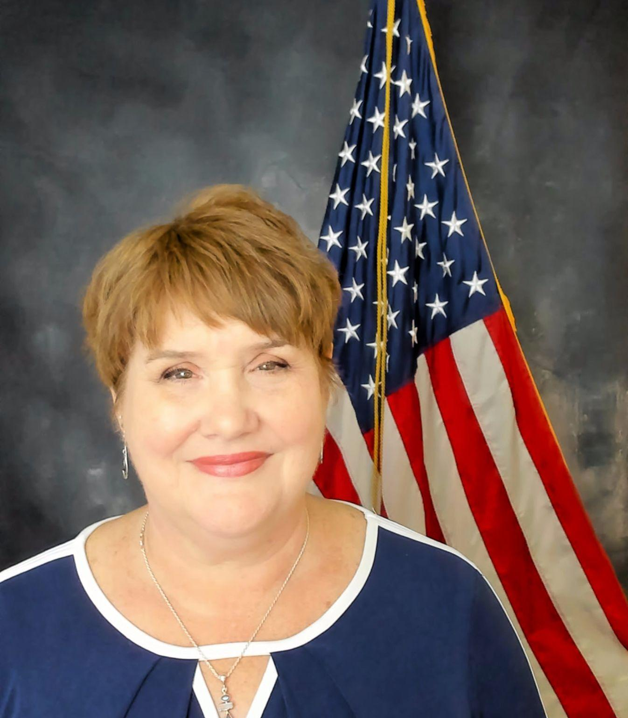  Lynn Gibbs-Scharf | IDAB Branch Chief, CDC/IDAB  Lynn Gibbs Scharf, MPH, is the Chief of the Informatics and Data Analytics Branch (IDAB) in the Immunization Services Division at CDC. She oversees efforts to advance IIS, advance technical and functional standards, establish the first national IIS surveillance system, and provide technical assistance to the awardees of the Immunization and Vaccines for Children cooperative agreement.  Lynn joined CDC as a member of the first class of CDC Public Health Prevention Service in 1997, after working as an epidemiologist in the Louisiana Office of Public Health. Since that time, she has served in a number of leadership positions at CDC, including Deputy Director for the Division of State and Local Readiness, Director of the Division of Alliance Management and Consultation in CDC's former National Center for Public Health Informatics, and Chief of the Knowledge Management Branch in the Office of State, Tribal, Local, and Territorial Support. Prior to joining NCIRD, Ms. Gibbs Scharf was the Director for the Office of Policy, Performance and Communications, and the Director of the Grant Solutions Project Management Office in the Office of Financial Resources where she ensured compliance with federal regulations for CDC’s $10 billion of acquisition and grant programs, led policy-related activities, and implemented CDC’s first end-to-end grants management system.
  Liz Hansen | Senior Advisor, GaHIN  Liz Hansen is an industry consultant, HIT informaticist and regulatory subject matter expert. With over 30 years of experience in Information Technology within the ambulatory and acute Healthcare settings, she is a recognized expert in Health Information Exchange, Promoting Interoperability, Quality Improvement and Practice Transformation. Liz serves as a Senior Advisor to the Georgia Health Information Network (GaHIN), facilitating innovative connections to support a statewide Community of Care and commitment to nationwide interoperability. She also participates in the quality improvement efforts sponsored by the Alliant Health Solutions Quality Improvement Network (QIN/QIO).  Liz has assisted thousands of providers through practices, health systems and ACOs in their successful efforts to achieve HIE connectivity, Meaningful Use, MIPs, Interoperability and Patient Centered Medical Home (PCMH). She holds certifications in Patient Centered Medical Home (PCMH CCE), MACRA (CMHP), Meaningful Use (CMUP) and HIPAA Compliance (CHSP, CHSP) and currently serves on the Sequoia Project Interoperability Data Usability Workgroup and the Civitas Learning Health Systems Workgroup.
  LaTreace Harris | Lead Health Scientist, CDC/IDAB  LaTreace Harris currently serves as the Lead Health Scientist and Team Lead for the Evaluation and Applied Analytics Team within the Immunization Services Division at CDC. For 20 months, she served as the Deputy Lead and Section co-lead of the Data Monitoring and Reporting Section within the CDC COVID-19 Vaccine Taskforce. She is also closely involved in the Data Modernization Initiative at CDC. LaTreace brings 18 years of experience at CDC to her role in the task force, with 10 of those spent in the Immunization Services Division.  LaTreace earned her undergraduate degree in biology from Clark Atlanta University. She completed her Master of Public Health in epidemiology from the Rollins School of Public Health at EmoryUniversity.
  Jeffeory H. White, MD, FAAP | Pediatrician and President/CEO, White’s Pediatrics  Dr. Jeffeory White has been a pediatrician in Northwest Georgia for 43 years. He currently owns and operates three full-service clinics in Dalton, Chatsworth, and Calhoun, as well as an urgent care center and a well-child clinic in Dalton.  He is a graduate of Loma Linda University School of Medicine in Loma Linda, California. He has served on several local boards & committees, including Hamilton Medical Center’s Board of Trustees, Wachovia Bank, and Southern Adventist University. He currently serves as Chairperson on the Board and Executive Committee for GaHIN, Chairperson for the GAAAP Medical Home Taskforce, and member of the Communications Committee for PHIC.
  Kristy Westfall | IIS Policy Associate Director, AIM  Kristy is the IIS Policy Associate Director at the Association of Immunization Managers – known as AIM – where she supports their members in the areas of IIS and data exchange. Prior to joining AIM in 2021, she worked for the Wyoming Immunization Program for 8 years in various roles including the IIS Manager and VFC Coordinator. She has worked in public health for over fourteen years.
PHII Staff
  Treonda Chapman | Informatics Analyst, PHII  As an informatics analyst, Treonda works directly with PHII project teams to document, analyze and translate their needs into technical designs and informatics solutions. In this role, she supports the teams in providing public health agencies with recommendations on informatics strategies, as well as with identifying technical solutions for electronic sharing of clinical and public health data. In addition, Treonda assists the team in identifying relevant standards to support programmatic needs, including vocabulary and terminology standards, information content standards, information exchange standards, privacy and security standards, functional standards and others as needed. She has more than 10 years of public health experience working on local, state and federal healthcare programs. Her work spans the areas of communicable disease epidemiology, health communication and health education. Treonda holds a MPH from Walden University as well as a BS in Biology from Alabama State University.  (E): tchapman@taskforce.org  (P): 404-687-5618
  Candace Garcia | Senior Informatics Analyst, PHII  Candace Garcia is a Senior Informatics Analyst with the Practice Support Unit in the Public Health Informatics Institute (PHII). Candace has 15 years of experience in healthcare management, including over a decade of experience in public health, specifically. Passionate about disease-prevention and the importance of immunizations for population health, Candace previously managed the City of Houston’s Health Department (HHD) Immunization Registry as well as the Vaccines for Children Program (VFC). Additionally, while at the HHD, Candace supported the Department’s implementation and use of the Epic electronic health record, later serving as the HHD’s Administration Manager of Epic. Candace holds an MBA in Management Information Systems as well as certifications in EpicCare Ambulatory and Epic Bridges Interfaces.  (E): cagarcia@taskforce.org  (P): 404-566-9655
  Hayleigh McCall McDavid | Project Manager, PHII  Hayleigh McCall McDavid is a Project Manager with PHII, supporting projects on IIS workforce development, automated audiology reporting, COVID-19 and respiratory disease surveillance through use of EHRs, and state and local health department informatics capacity assessment. The majority of her career has been spent in the nonprofit public health sector, previously acting as the lead on CDC-funded projects–focusing on syndromic surveillance, environmental and disaster epidemiology, and climate and health–at the Council of State and Territorial Epidemiologists (CSTE). Her other roles have included delivery of STLT disease surveillance systems solutions, federal emergency preparedness and response, and health communications. Hayleigh holds a MPH in Epidemiology as well as a BS in Microbiology and Psychology from the University of Georgia.  (E): hmcdavid@taskforce.org  (P): 404-592-1413
  Tony Winters | Project Team Lead, Informatics, PHII  Tony Winters serves as a project team lead for PHII where he leds the PHII’s immunization portfolio. He originally joined PHII as a senior informatics analyst; prior to this role, he was a fellow in the Centers for Disease Control and Prevention (CDC)’s Public Health Informatics Fellowship Program. He worked in Allentown, Penn., with the Lehigh Valley Health Network’s (LVHN) Pool Center for Health Analytics, LVHN’s Leonard Parker Pool Institute for Health and the Allentown Health Bureau. Tony helped these organizations develop cross-sector partnerships and infrastructure to create a new analytical platform to improve the health of the local community. Tony has also worked with CDC as an ORISE Fellow and contractor under the National Notifiable Disease Surveillance System Modernization Initiative.  Tony holds a doctorate in public health leadership from Georgia Southern University. He also holds a Master of Science in Public Health in applied epidemiology from the University of Alabama at Birmingham, where he earned his undergraduate degree, a Bachelor of Science in chemistry.  (E): twinters@taskforce.org  (P): (678) 681-9338

Participant List

States/Territories
Colorado  Kim Gulliver  CIIS and Data Ops Manager  kim.gulliver@state.co.us | Puerto Rico  Carieyshla Soto  EHR Analyst/Data QualityAnalytic Manager  soto.candelaria@salud.pr.gov
Guam  Adrian Banu  Systems Programmer  adrian.banu@dphss.guam.gov | San Antonio  Michelle Gilstrap  Immunizations Program Manager  Michelle.Gilstrap@sanantonio.gov
Houston  Rachel Woods  IIS Manager  Rachel.Woods@houstontx.gov | Danielle Howard  IIS Manager  Danielle.Howard@sanantonio.gov
Mariola Guerra  Management Analyst II  Mariola.Guerra@houstontx.gov | South Carolina  Kaji Keya-Korotki  IIS Manager  caitlin.newhouse@tn.gov
Montana  Atalyssa Neace  IIS Lead  atalyssa.neace@mt.gov | Tennessee  Ashley Pasquariello  IIS Manager  ashley.pasquariello@tn.gov

Day 1 – Tuesday, June 4, 2024

Welcome and Workshop Overview
Facilitators: Beth Cox and Tony Winters
Notes

Role of an IIS Leader
Facilitator: Amy Metroka
Learning Objectives and Key Resources
Learning Objectives:
- Understand the key responsibilities of an IIS leader
- Recognize the IIS leader’s critical responsibility for building a strong and effective team
  - Identify staff roles needed to successfully operate an IIS
  - Learn about IIS community resources to assess staffing and fill gaps

Key Resources:
- IIS Core Competency Model - defines 11 core competencies for the IIS team
  - https://phii.org/resources/iis-core-competency-model/
- Sample IIS Staffing Model - helps visualize coverage for key IIS staff roles and gaps
  - https://phii.org/wp-content/uploads/2021/07/MT-Sample-IIS-Staffing-Model.pptx
- IIS Workforce Classifications - guides identification of staffing needs and recruitment
  - https://phii.org/resources/iis-workforce-classifications/
- Staff Allocation Matrix - helps assess current and planned staff allocations and capacity
  - https://phii.org/wp-content/uploads/2021/07/MT-Staff-Allocation-Matrix.xlsx
- IIS Staff Roles Matrix - helps identify staffing responsibilities for key IIS roles
  - https://phii.org/wp-content/uploads/2021/07/MT-IIS-Staff-Roles-Matrix.xlsx
- CDC IIS Data Quality Blueprint - guide to address and advance IIS data quality characteristics
  - https://www.cdc.gov/vaccines/programs/iis/downloads/Data-Quality-Blueprint-508.pdf
- CDC IIS Dashboard - identifies jurisdiction-specific data quality strengths and challenges
  - https://wwwn.cdc.gov/IISDashboard/Query.aspx
- AIRA Aggregate Analysis Reporting Tool (AART) Tool - an application developed to visualize and compile results and information on community-driven measures and tests related to IIS Functional Standards
  - https://www.immregistries.org/aggregate-analysis-reporting-tool
- CDC Functional Standards and Operational Statements - describes the operations, data quality, and technology needed by IISs to support immunization programs and partners
  - https://www.cdc.gov/vaccines/programs/iis/functional-standards/func-stds-v4-1.html
- Data Modernization for IIS One-Pager Guide - steps for immunization information system (IIS) staff to learn more about the Data Modernization Initiative
  - https://phii.org/wp-content/uploads/2023/04/DMI-IIS-one-pager_Final.pdf
- Immunization Program Operations Manual (IPOM) - provides VFC/317 immunization programs
with the requirements to meet objectives (on CDC Sharepoint site)

Notes

Activity: Word Cloud
What does leadership mean to you?

Instructions:
Via the MentiMeter, identify some words or terms that describe what leadership means to you.

Activity: IIS Staffing Model
Instructions:
- Read the IIS Staffing Model in your folder and think about how your current IIS team compares to the model - 5 minutes
- Go to the IIS Staffing Model posted on the back wall and attach dots indicating which roles are covered (green), partially covered (yellow), and not covered (red) among your current IIS team - 5 minutes
- Return to your table to participate in a group discussion about your findings and how to fill staffing gaps - 5 minutes

Activity: Discussion
Discussion Questions:
- Where are you strongest as an IIS leader?

- Where are you interested in growth?

CDC and the IIS Community
Facilitator: Beth Cox
Learning Objectives and Key Resources
Learning Objectives:
- Understand what an Immunization Information System (IIS) is and the purpose of an IIS
- Understand how the IIS supports the Immunization Program through 317/VFC CoAg activities
- Learn how to use the following CDC tools to improve IIS data quality:
  - IIS Blueprint
  - IIS Dashboard
  - Routine Vaccination Submission Data Quality Report
  - PPRL Data Quality Report
  - IIS Functional Standards
- Understand the Immunization Services Division (ISD) structure
- Understand how ISD communicates and engages with jurisdictions

Key Resources:
- IIS Functional Model - visual representation of the baseline functions, capabilities and attributes of a standard Immunization Information System (IIS)
  - https://phii.org/wp-content/uploads/2021/08/PHII_IISFunctionalModel_simple_FINAL.pdf
- IIS Data Quality Blueprint - guide to address and advance IIS data quality characteristics
  - https://www.cdc.gov/vaccines/programs/iis/downloads/Data-Quality-Blueprint-508.pdf
- IIS Functional Standards - describes the operations, data quality, and technology needed by IISs to support immunization programs and partners
  - https://www.cdc.gov/vaccines/programs/iis/functional-standards/func-stds-v4-1.html
- IIS Functional Standards Resource Guide - guidance and best practices to assist in implementing the standards
  - https://www.cdc.gov/vaccines/programs/iis/functional-standards/func-stds-v4-1-resource-guide.pdf
- IIS Dashboard and Data Quality Reports - evaluates routine vaccination data submissions against data quality goals and targets set by the IIS Data Quality Blueprint Indicators and AIRA completeness recommendations.
  - https://wwwn.cdc.gov/iisdashboard/Query.aspx
- PPRL Submission Data Quality Report - high-level feedback and actions a jurisdiction can take to improve IIS data quality

Notes

Activity: IIS Dashboard
Instructions:
- Review your IIS Dashboard printout
- Identify which targets your jurisdiction are meeting/not meeting?

  - Are there strategies to maintain your targets/opportunities for improvement?

  - What discussions should you have and with whom to champion improvement (e.g., immunization program manager, vendor, other?)

- Discuss strategies/opportunities with your ‘assigned’ IIS SME
  - Large group discussion of key themes

Networking Event: IIS Trivia
Facilitator: Hayleigh McCall McDavid
Notes

Data Quality
Facilitators: Mary Beth Kurilo and LaTreace Harris
Learning Objectives and Key Resources
Learning Objectives:
- Develop an understanding of core data quality concepts and themes
- Apply foundational documents in considering aspects of your system’s data quality (e.g., CDC Blueprint and Dashboard, AIRA Measurement and Improvement Content Areas, etc.)
- Understand and be able to identify multiple points of intervention for improving your system’s data quality
Key Resources:
- CDC IIS Data Quality Blueprint - guide to address and advance IIS data quality characteristics
  - https://www.cdc.gov/vaccines/programs/iis/downloads/Data-Quality-Blueprint-508.pdf
- Data Validation Guide for the IIS Onboarding Process - provides recommendations on the data validation process within onboarding
  - https://repository.immregistries.org/resource/data-validation-guide-for-the-iis-onboarding-process/
- IIS Data Quality Practices: Monitoring and Evaluating Data Submissions - focuses on the ongoing data monitoring and evaluation process for incoming data submissions
  - https://repository.immregistries.org/resource/iis-data-quality-practices-monitoring-and-evaluating-data-submissions/
- IIS Data Quality Practices: To Monitor and Evaluate Data at Rest - provides practical guidance on techniques, methodologies, and processes for IIS to use in assessing the quality of data at rest
  - https://repository.immregistries.org/resource/iis-data-quality-practices-to-monitor-and-evaluate-data-at-rest/
- Data Quality Assurance in Immunization Information Systems - provides best practice recommendations that support and sustain high-quality data in IIS
  - https://repository.immregistries.org/resource/data-quality-assurance-in-immunization-information-systems/
- AIRA Aggregate Analysis Reporting Tool (AART) Tool - an application developed to visualize and compile results and information on community-driven measures and tests related to IIS Functional Standards
  - https://app.immregistries.org/aart/home/
- Onboarding Consensus-Based Recommendations - guidance to promote best practices for provider onboarding to IIS
  - https://repository.immregistries.org/resource/onboarding-consensus-based-recommendations/

Notes

Activity: Your System’s Data Quality - A Brief Assessment
Instructions:
Via the MentiMeter, assess your system’s data quality by answering the following
questions.

Menti Scale Questions (scale of 1-5, with 5 being most important)

- What is the level of importance of DQ to you as a leader?
- What is the level of importance of DQ to your data exchange partners?

Qualitative Questions (free text):

- Where is your system strong with DQ?
- What are your most significant DQ priorities?

Activity: Upstream, Downstream, Where to Fish
Instructions:
The work to influence data quality (DQ) within an IIS can take many forms. This exercise is meant to stimulate thinking and conversation about what DQ approaches can be leveraged to improve IIS data quality, and where interventions might be possible. There is no one right answer, but rather multiple opportunities, to achieve high quality data. Considering the upstream and downstream aspects of DQ, where and how might you intervene?
- Each table will get one data quality scenario
- Participants will answer these four questions, writing high-level notes on the flip charts:
  - What problem are we addressing (i.e., what fish are we looking for?)

  - Where is the root cause (i.e., where are the big fish)?

  - What can I do about it (i.e., how do I catch them)?

  - What resources could help me (i.e., what’s the best bait)?

- When groups are finished, they will rotate to another group’s responses, reviewing and adding to them with a “Yes, and…” or “But wait, what about…” approach with the speech bubble sticky notes
- Share highlights with the larger group

Activity: High Priorities Moving Forward
Instructions:
- Come back to your high priority areas you shared at the start of this session
  - Share your high priorities with the rest of your table
    - Are there any commonalities/overlapping priorities?
  - Makes notes on note paper
  - Share highlights with the larger group

AIRA Overview
Facilitator: Rebecca Coyle
Learning Objectives and Key Resources
Learning Objectives:
- Grow your understanding of AIRA as a member organization
- Expand your knowledge of AIRA resources to support technical, operational and policy program areas
- Discuss and determine where key program staff can engage with workgroups, committees, user groups, and peers to further develop skills

Key Resources:
- AIRA Repository - section of the AIRA website where resources (previous webinar slides, meeting presentations, articles) can be found
  - https://repository.immregistries.org/
- AIRA Events Calendar - online calendar detailing upcoming events and activities across the IIS community
  - https://www.immregistries.org/calendar
- AIRA Aggregate Analysis Reporting Tool (AART) Tool - an application developed to visualize and compile results and information on community-driven measures and tests related to IIS Functional Standards
  - https://www.immregistries.org/aggregate-analysis-reporting-tool
- TA Request Form - an online form for submitting requests for technical assistance for any IIS-related topics
  - https://www.immregistries.org/request-technical-assistance

Notes

Activity: Discussion
Discussion Questions:
- Have you accessed any helpful AIRA resources or attended any meetings (or any sessions at the National Meeting) that were especially useful?

- Are there any resources you would recommend to your peers?

Activity: AIRA Opportunities for You and Staff
Instructions:
- Review the AIRA Opportunities Worksheet (included on next page) - events also found at: https://www.immregistries.org/calendar
- Think about those areas that might be especially useful for you and/or your teammates to be engaged in
- Capture your thoughts in the worksheet within your workbook, and discuss with your small group
- Large group discussion of key ideas/thoughts

AIRA Opportunities Worksheet
Workgroups and Committees | Purpose | Schedule  (if applicable) | Is my Jurisdiction Involved? Who? | Notes and Follow Up
Standards and Interoperability Steering Committee (SISC) | SISC provides technical support and guidance to interoperability efforts of AIRA members and the IIS community. It acts as a liaison between national organizations involved with interoperability and serves as a technical resource for the IIS community. | Open - Monthly, typically on the 2nd Wednesday at 1 p.m. ET
Workgroups and Committees | Purpose | Schedule  (if applicable) | Is my Jurisdiction Involved? Who? | Notes and Follow Up
HL7 User Group | The HL7 User Group is a joint effort with the HL7 International organization. The user group provides an opportunity for IIS and electronic health record (EHR) partners to troubleshoot and resolve messaging challenges. | Open to HL7 voting members - Monthly, typically on the 2nd Thursday at 2 p.m. ET
Measurement for Assessment and Certification Advisory Workgroup (MACAW) | MACAW is charged with systematically researching and formulating key IIS assessment components, developing pilot metrics and implementing IIS assessment. The workgroup will also recommend measures and phases as the validation process is finalized and adopted by the IIS community. | By invitation - Monthly
Smarty Address Cleansing and Geocoding User Group | The Smarty Address Cleansing and Geocoding User Group brings together Smarty implementers and users to assist IIS in their initial set-up, help them troubleshoot any issues, share uses and successes, and encourage peer-to-peer relationships among the jurisdictions and platforms. | Open - Quarterly, typically on the 3rd Wednesday of the second month of the quarter at 2 p.m. ET
Workgroups and Committees | Purpose | Schedule  (if applicable) | Is my Jurisdiction Involved? Who? | Notes and Follow Up
Tableau User Group (TUG) | TUG brings together IIS staff and implementers to demonstrate how Tableau can be used to achieve members’ various data visualization needs, share Tableau successes and lessons learned, help members troubleshoot Tableau issues, and encourage the implementation of data visualization tools. | Open - Monthly, typically on the 4th Tuesday at 12 p.m. ET (alternating with Power BI)
Power BI User Group | Power BI User Group invites IIS community members to a bi-monthly conversation where participants engage in peer-to-peer sharing, synergize Power BI efforts across jurisdictions, and consolidate and disseminate Power BI resources. | Open - Bimonthly, typically on the 4th Tuesday at 12 p.m. ET (alternating with Tableau)
Immunization Integration Program (IIP) Executive Counsel | The Executive Committee of the Immunization Integration Program (IIP), a collaboration with HIMSS and AIRA and supported by CDC, brings together clinicians, EHR developers, IIS, public health, health information exchanges (HIEs) and other key stakeholders to improve interoperability, information sharing and management. | By invitation - Bi-Monthly
Workgroups and Committees | Purpose | Schedule  (if applicable) | Is my Jurisdiction Involved? Who? | Notes and Follow Up
AIRA Board of Directors | The AIRA Board of Directors is a volunteer board of IIS program and partner members that govern AIRA activities. | Elected - Monthly
AIRA Executive Committee | The AIRA Executive Committee is made up of members of the AIRA Board who serve as officers (President Elect, President, Treasurer, Secretary). | Elected - Monthly
Events | Purpose | Schedule  (if applicable) | Is my Jurisdiction Involved? Who? | Notes and Follow Up
AIRA members and partners meeting | This meeting provides updates from the AIRA staff as well as partner agencies (e.g., CDC, AIM, ONC, PHII, etc.) | Open – Quarterly, typically on the 3rd Monday at 2 p.m. ET
Events | Purpose | Schedule  (if applicable) | Is my Jurisdiction Involved? Who? | Notes and Follow Up
Discovery sessions | Discovery sessions address timely and relevant topics of interest for new and existing IIS and immunization program staff. | Open - Monthly, typically on the 4th Monday at 4 p.m. ET
AIRA Annual National Meeting | The AIRA Annual National Meeting is a multi-day event providing a forum for IIS programs and partners to present information, attend sessions, participate in workshops and network with peers. | Open - Annual (in-person in Spokane in 2025)

Activity: Interest Cards
Instructions:
- Take a minute to fill out an interest card or two to let AIRA know to follow up with you or your team members

Activity: AIRA Opportunities for You and Your Staff
Instructions:
- Share your group’s collective input with the larger group

Communication
Facilitator: Marcey Propp
Learning Objectives and Key Resources
Learning Objectives:
- Understand the critical role of communication in building support of the IIS
- Learn the building blocks in developing a robust communication plan
- Identify key internal and external partners for IIS communication
- Draft communication plan strategies and key messages tailored to sample partners or groups

Key Resources:
Tools and resources that can be used to inform and complement your Communications Plan are available in the IIS Operations Toolkit at https://phii.org/what-we-do/iis-hub/iis-operations/. These include:
- Communications Plan Template - instructions and samples to complete a comprehensive communication plan
- Partner Analysis Workbook
  - Partner Analysis Worksheet - to identify various partners to communicate with
  - Partner Analysis Matrix - a 2x2 matrix to determine the level of interest and influence a partner may have
- Change Management Workbook - to map out/complete communication activities

Notes

Activity: Partner Analysis Matrix
Instructions:
As a table, identify 2-3 key partners and indicate within the Partner Analysis Matrix (on next page) their:
- Level of interest
- Power of influence

Based on your small group discussions, identify in the larger group:
- Who might be strong advocates of your IIS (high/high)?

- What relationships might be strengthened through communication?

Key Partner Matrix
 |  | Power to Influence
 |  | High | Low
Level of Interest | High
Level of Interest | Low

Activity: Strategies and Key Messages
Instructions:
Using the Strategies and Key Messages table (below), consider one of the partners listed in the previous activity and determine:
- Strategy(ies) needed to communicate with this partner
- Key messages tailored to their use/need of the IIS
Strategies and Key Messages Table
Partner / Group | Communication Strategy  - Raise awareness  - Educate / train  - Seek input  - Update / inform | Key Messages

World Cafe
Facilitator: Tony Winters
Notes

Day 1 Wrap-Up
Leadership Action Plan
Activity: Leadership Action Plan
Think about the modules discussed today, and write down on the Leadership Action Plan worksheet goal(s) that you would like to accomplish as an IIS/immunization leader as well as the details necessary to help accomplish those goals.

Day 2 – Wednesday, June 5, 2024

Day 2 Welcome and Recap
Facilitator: Tony Winters
Notes

Lightning Round
Facilitator: Tony Winters
Notes
- What are your aspirations for the coming year?

- What are some pain points or barriers you anticipate encountering while trying to achieve your goals?

- What steps or resources would aid in achieving success?

- What are some things that are working well for you and your team?

Coffee Klatch
Facilitators: Workshop Faculty
Notes
- What is on your mind? Let’s network and talk.

Effective IIS Data Use
Facilitator: Amy Metroka
Learning Objectives and Key Resources
Learning Objectives:
- Understand the connection between data quality and data use
- Apply the SIPOC tool to identify the key Suppliers, Inputs, Processes, Outputs and Consumers of IIS data
- Identify the internal and external partners who can use IIS data to increase up-to-date immunization of individuals and populations
- Recognize the potential impact of data visualization on increasing IIS data access, use, and awareness by the public and partners
Key Resources:
- CDC Core Data Elements for IIS Functional Standards v4.1 - list of CDC-endorsed data elements
  - https://www.cdc.gov/vaccines/programs/iis/functional-standards/func-stds-v4-1.html
- CDC IIS HL7 Version 2.5.1 Implementation Guide (IG) and Addendum - guide for EHR vendors, immunization providers, and other partners to implement standards-based data exchange with an IIS
  - https://www.cdc.gov/vaccines/programs/iis/technical-guidance/downloads/hl7guide-1-5-2014-11.pdf
- AIRA Onboarding Guidance and Shared Services - supports awardee jurisdictions with onboarding providers to their local IIS
  - https://www.immregistries.org/onboarding-shared-services
- AIRA Aggregate Analysis Reporting Tool (AART) - an application developed to visualize and compile results and information on community-driven measures and tests related to IIS Functional Standards
  - https://www.immregistries.org/aggregate-analysis-reporting-tool

Notes

Activity: Small Group Discussion
Instructions:
Discuss the questions below with your table, and designate one person to report out for your group.
- What data use challenges are you facing now?

- How can you work to overcome them?

After 15 minutes, return to your table to hear a report out from each group and engage in a large group discussion.

IIS Functional Standards
Facilitators: Beth Cox and Marcey Propp
Learning Objectives and Key Resources
Learning Objectives:
- Understand the role of the IIS functional Standards in building an efficient, effective and sustainable IIS.
- Determine the ways the Functional Standards can be used within your agency and who might use them.
- Identify your role as an IIS leader in achieving the Functional Standards.

Key Resources:
- CDC Core Data Elements for IIS Functional Standards v4.1 - describe the operations, data quality, and technology needed by IISs to support immunization programs, vaccination providers, and other immunization stakeholders
  - https://www.cdc.gov/vaccines/programs/iis/functional-standards/func-stds-v4-1.html
- IIS Functional Standards Version 4.1 Resource Guide - guidance and best practices to assist in implementing the standards
  - https://www.cdc.gov/vaccines/programs/iis/functional-standards/func-stds-v4-1-resource-guide.pdf
- IIS Baseline Requirements Traceability Matrix (RTM) - draft baseline functional and non-functional requirements for an immunization information system (IIS) to clarify minimum expectations for what IIS technology must do and how it must operate to support IIS Functional Standards and programmatic and immunization stakeholder needs
  - https://phii.org/download/requirements-traceability-matrix/?wpdmdl=12184&masterkey=6115821124c2a

Notes

Activity: Using the Functional Standards
Instructions:
With those at your table, answer the following:
- How do/might you use the functional standards?

- With whom do/would you engage to achieve them?

- What potential challenges do/might you have?

Discuss key thoughts with the larger group.

The “IIS View”
Panelists: Liz Hansen, Dr. Jeffeory White, Dr. Kathryn Cheek
Facilitator: Mary Beth Kurilo
Notes

Networking Event: Bingo
Facilitator: Hayleigh McCall McDavid
Notes

PHII Overview
Facilitator: Tony Winters
Learning Objectives and Key Resources
Learning Objectives:
- Build your understanding of PHII as a public health program
- Expand your knowledge of PHII resources to support workforce development and technical assistance of IIS teams
- Determine opportunities to engage for your IIS and your team

Key Resources:
- IIS Learning Hub - one-stop shop for all PHII IIS resources
  - https://phii.org/what-we-do/iis-hub/
- PHII LMS Portal - PHII learning management system of IIS and other public health topic eLearning courses (free of cost)
  - https://www.informaticsacademy.org/
- IIS Workforce Classifications - 12 IIS-specific job descriptions
  - https://phii.org/resources/iis-workforce-classifications/
- IIS Operations Toolkit - tools to help with day to day IIS operations
  - https://phii.org/what-we-do/iis-hub/iis-operations/
- IIS Procurement Toolkit - guide to navigating procurement of IT services
  - https://phii.org/course/iis-procurement-toolkit/
- IIS Baseline Requirements Traceability Matrix (RTM) - draft baseline functional and non-functional requirements for an immunization information system (IIS) to clarify minimum expectations for what IIS technology must do and how it must operate to support IIS Functional Standards and programmatic and immunization stakeholder needs
  - https://phii.org/download/requirements-traceability-matrix/?wpdmdl=12184&masterkey=6115821124c2a
- IIS Migration Toolkit - tools to help successfully migrate to a new IIS platform
  - https://phii.org/course/iis-migration-toolkit/

Notes

Activity: Can You Identify These PHII Resources

Instructions:
Via the MentiMeter, test your knowledge and identify useful PHII resources.

Change Management, Project Management, and the Systems Development Life Cycle
Facilitator: Marcey Propp
Learning Objectives and Key Resources
Learning Objectives:
- Understand how change management differs from project management
- Recognize how they complement each other and why they are crucial to a successful systems transition/IT project
- Utilize the PHII project management framework and tools as foundational resources in managing program transitions

Key Resources:
- Change Management Tools - guidance on change management activities that assist internal staff and external partners through transition
  - https://phii.org/module-unassigned/plan-phase-overview-2/
- Project Management Framework - guidance to initiate, plan, execute, monitor and control, and close an IIS project
  - https://phii.org/wp-content/uploads/2021/06/MT-Migration-Project-Management-Framework.pdf
- IIS Functional Model - a framework and terminology for conveying and communicating the core functions, capabilities and attributes of an Immunization Information System (IIS)
  - https://phii.org/wp-content/uploads/2021/08/PHII_IISFunctionalModel_simple_FINAL.pdf
- IIS Baseline Requirements Traceability Matrix (RTM) - draft baseline functional and non-functional requirements for an immunization information system (IIS) to clarify minimum expectations for what IIS technology must do and how it must operate to support IIS Functional Standards and programmatic and immunization stakeholder needs
  - https://phii.org/download/requirements-traceability-matrix/?wpdmdl=12184&masterkey=6115821124c2a
- RAID Log - a centralized source of Risks (R), Actions (A), Issues (I) and Decisions (D) identified and tracked throughout a project and a convenient means of distributing it to project team members and stakeholders. Reviews and edits to the RAID log contents are commonly facilitated by the project manager during weekly project team meetings.
  - https://phii.org/wp-content/uploads/2021/07/MT-RAID-Log_TEMPLATE_0.xlsx

Notes

Activity: Word Cloud
Instructions:
Via the MentiMeter, identify some of the terminology/technology of this new era…
- IZ Gateway
- Data Modernization
- Others?

Activity: Change Readiness Assessment
Instructions:
Via the MentiMeter, consider the following:
- Thinking about your organization, answer the following Yes/No questions:
  - Most changes in my organization in the past have been implemented
successfully
  - Leadership in my organization are visible and active change leaders and
sponsors
  - My organization encourages and rewards staff who promote change and introduce new ideas
  - My management team is receptive to feedback and alternative ideas and encourages open communication
- Discuss your responses with the larger team.

Activity: SWOT(lite) Discussion
Instructions:
Within your team, use the matrix (on the next page) to:
- Identify 1-2 strengths of your IIS
- Identify 1-2 opportunities for enhancement you would like to make in your IIS
- Identify a spokesperson to read out your group’s answers to the broader group

Strengths, Weaknesses, Opportunities, and Threats (SWOT) Matrix
IIS Strengths | IIS Weaknesses
IIS Opportunities | IIS Threats

Day 2 Wrap-Up
Leadership Action Plan
Activity: Leadership Action Plan
Think about the modules discussed today, and write down on the Leadership Action Plan worksheet goal(s) that you would like to accomplish as an IIS/immunization leader as well as the details necessary to help accomplish those goals.

Day 3 – Thursday, June 6, 2024

Day 3 Welcome and Recap
Facilitator: Tony Winters
Notes

Laws, Policies and Procedures
Facilitators: Mary Beth Kurilo and Beth Cox
Learning Objectives and Key Resources
Learning Objectives:
- Increase understanding about how your jurisdiction’s laws, policies, and procedures can impact IIS and Immunization Program goals
- Explore important benefits and risks of modifying laws, policies, and procedures
- Discuss how federal initiatives and related policy requirements affect state and local IIS implementation and IIS data
- Expand understanding for how Standard Operating Procedures (SOPs) can ensure your team aligns with policy and law

Key Resources:
- Awardee Sharepoint Site Policy Document Folder
  - APHL DUA
  - Interjurisdictional MOU
  - Share Task Order, Appendix A of APHL DUA
  - IIS-CDC Task Order, Appendix B of APHL DUA (see above)
  - IZ Gateway Multi-Jurisdiction Vaccine Provider Jurisdiction Data Exchange Agreement (JPA)
  - CDC COVID-19 DUA (current)
  - CDC Routine and Seasonal Flu Immunization DUA
  - Business Associate Agreement (BAA)
- AIRA Repository
  - AIRA Confidentiality and Privacy Considerations for IIS - assists IIS as they develop policies and procedures to meet legal requirements for protecting the privacy of individuals and the confidentiality of information in IIS
    - https://repository.immregistries.org/resource/aira-confidentiality-and-privacy-considerations-for-iis/
  - Public Health Inter-jurisdictional IIS MOU Template - provides a fillable form for a MOU for secure, electronic exchange of immunization information among governmental entities that operate a population-based IIS
    - https://repository.immregistries.org/resource/public-health-iis-interjurisdictional-memorandum-of-understanding-mou/
  - IIS Policies to Support Pandemic and Routine Vaccination One-Sheet - highlights areas to focus on strengthening policy related to data exchange, vaccine reporting and consent to achieve more uniform, consistent policies
    - https://repository.immregistries.org/resource/iis-policies-to-support-pandemic-and-routine-vaccination-one-sheet/from/major-iis-topics/policy/
  - Immunization Program Policy Toolkit - designed to equip members of the Association of Immunization Managers (AIM) and their staff with the tools and information necessary to appropriately and effectively engage with elected officials
    - https://www.immunizationmanagers.org/page/Policytoolkit

Notes

Activity: Discussion
Discussion Questions:
Are there areas of your current legislation that your program or others within your jurisdiction would like to consider changing in the future? If so, what are they? Who are likely to be allies and opponents of the change?

Consider:
- Jurisdiction trends focused on privacy
- Impact on what a jurisdiction shares and what it receives
- Managing expectations and gatekeeping on data needs

Activity: Discussion Questions
Instructions:
Via the MentiMeter, provide your responses to the following questions.

On a scale of 1-5, where would you place your jurisdiction in timely, complete documentation of needed standard operating procedures?

- 1 = no procedures documented
- 3 = some procedures documented, but not necessarily complete or current
- 5 = all procedures are fully documented and updated

What are your most high-priority SOPs to document in the next three months?

Networking Event: CDC SME Session
Facilitators: CDC IIS SMEs
Notes

IIS Budget and Sustainability
Facilitator: Jan Hicks-Thomson
Learning Objectives and Key Resources
Learning Objectives:
At the end of the module, you will be able to:
- Define Strategic Sustainability
- Learn about current funding opportunities and considerations
- Explore potential new partnerships to diversify and sustain funding
- Consider cost-sharing and cost-lowering approaches
- Identify how to best make decisions in the context of long-term sustainability
- Understand the components needed to build an Immunization Information Systems (IIS) budget
- Consider your workforce and how to support and maintain the IIS core functions

Notes

Activity: Discussion
Discussion Questions:
- What IIS strategic sustainability topics are you interested in learning more about?

- What kind of assistance would help you find what you need?

Activity: Discussion
Instructions:
- Name one new partnership that might help your program diversify and sustain funding in the future.

Activity: SWOT-lite
Instructions:
- A Partial SWOT: Consider the Opportunities and Threats for your IIS
  - In small groups, discuss the Opportunities and Threats for your system at this time
  - Share your group’s collective input with the larger group
  - Consider the SWOT from the Change Management Module: What is a line item from it that you might add to your budget?

Activity: Assess Your Workforce
Instructions:
Scenario – Use the Year 4 submitted staff and compare the roles to the PHII Workforce Role Descriptions.

Questions:
- How does your organization’s current staff map to the IIS Workforce Role Descriptions?
- What roles, if any, don’t map to available role descriptions?

IIS Assessment, Planning and Prioritization
Facilitator: Mary Beth Kurilo
Learning Objectives and Key Resources
Learning Objectives:
- Revisit and broaden knowledge of available data sources and resources to assess the capabilities of an IIS
- Consider the short- and long-term planning and prioritization needed to meet programmatic goals and make sustainable investments
- Explore the benefits and opportunity costs inherent in programmatic decisions and actions

Key Resources:
- CDC Data Quality Reports - identifies jurisdiction-specific data quality strengths and challenges
  - https://wwwn.cdc.gov/IISDashboard/Query.aspx
- AIRA Aggregate Analysis Reporting Tool (AART) - an application developed to visualize and compile results and information on community-driven measures and tests related to IIS Functional Standards
  - https://www.immregistries.org/aggregate-analysis-reporting-tool
- IIS Functional Model - a framework and terminology for conveying and communicating the core functions, capabilities and attributes of an Immunization Information System (IIS)
  - https://phii.org/wp-content/uploads/2021/08/PHII_IISFunctionalModel_simple_FINAL.pdf
- IIS Learning Hub - one-stop shop for all PHII IIS resources
  - https://phii.org/what-we-do/iis-hub/
- IIS Project Governance Worksheet - defines roles among the project team to help identify who is ultimately responsible for managing specific project tasks and establishes a common set of expectations around project accountabilities
  - https://phii.org/wp-content/uploads/2021/07/MT-Project-Governance-Roles-and-Responsibilities-Worksheet.docx
- IIS Staff Roles Matrix - helps identify staffing responsibilities for key IIS roles and responsibilities
  - https://phii.org/wp-content/uploads/2021/07/MT-IIS-Staff-Roles-Matrix.xlsx

Notes

Activity: Prioritization Strategies
Instructions:
- Discuss the following with your table.
- Think about the opportunities we generated in the SWOT Exercise on Day 2:
  - What were your top opportunities for your program?

  - What is one common priority your group today can agree on?

  - What are the next steps to put this high priority opportunity into action?

- Select a spokesperson for your group
- Spend ~5 minutes discussing priorities, deciding on a common priority, and determining how you might take action on it
- When we come back together, each group presents a 1-2 minute elevator pitch for leadership on why their priority is critical

Vision for IIS from CDC
Facilitator: Lynn Gibbs-Scharf
Notes

IIS Strategic Vision Panel
Panelists: Rebecca Coyle, Lynn Gibbs-Scharf, Kristy Westfall, Tony Winters
Facilitator: Beth Cox
Notes

Day 3 Wrap-Up
Leadership Action Plan
Activity: Leadership Action Plan
Think about the modules discussed today, and write down on the Leadership Action Plan worksheet goal(s) that you would like to accomplish as an IIS/immunization leader as well as the details necessary to help accomplish those goals.

Appendix A: Common IIS Acronyms

Below are some acronyms you might encounter during the workshop or in public health overall. For newcomers to the world of IIS, these terms can be confusing. For the initiated and seasoned staffer, many of the acronyms relating to the IIS are so common that often people recognize the concept without knowing what all of the letters stand for. Please use this list during the workshop to support your understanding.

AAP American Academy of Pediatrics
ACIP Advisory Committee on Immunization Practices
AHIP America’s Health Insurance Plans
AIM Association of Immunization Managers
AIRA American Immunization Registry Association
APHL Association of Public Health Laboratories
ASPR Administration for Strategic Preparedness and Response
ASTHO Association for State and Territorial Health Officials
AVAC Adult Vaccine Access Coalition
CDC Centers for Disease Control and Prevention
CDSi Clinical Decision Support for immunization
CMS Centers for Medicare and Medicaid Services
CoAg Cooperative Agreement
CSTE Council of State and Territorial Epidemiologists
DQ Data Quality
DMI Data Modernization Initiative
DSA Data Sharing Agreement
DUA Data Use Agreement
EDI Electronic Data Exchange
EHR Electronic Health Record
EHRA Electronic Health Record Association
EMR Electronic Medical Record
FAQ Frequently Asked Questions
FHIR Fast Healthcare Interoperability Resources
FM Functional Model
FQHC Federally Qualified Health Center
FS Functional Standards
HEDIS Health Plan Employer Data and Information Set
HHS Department of Health and Human Services
HIMSS Health Information and Management Systems Society
HIPAA Health Insurance Portability and Accountability Act
HL7 Health Level Seven
IDAB Informatics Data and Analytics Branch (formerly referred to as IISSB)
IHS Indian Health Service
IG Implementation Guide
IIP Immunization Integration Program
IIS Immunization Information Systems
IISAR Immunization Information Systems Annual Report
IPOM Immunization Program Operations Manual
IQIP Immunization Quality Improvement Program
ISD Immunization Services Division
IT Information Technology
IV&V Independent Verification and Validation
IZ Gateway Immunization Gateway
JPHIT Joint Public Health Informatics Taskforce
MACAW Measurement for Assessment and Certification Advisory Workgroup
MIROW Modeling of Immunization Registry Operations Workgroup
MOU Memorandum of Understanding
NACCHO National Association of County and City Health Officials
NCIRD National Center for Immunization and Respiratory Diseases
NCQA National Committee for Quality Assurance
NIST National Institute of Standards and Technology
NPHL Network for Public Health Law
NSA North Star Architecture
NVAC National Vaccine Advisory Committee
NPRM Notice of Proposed Rule Making
OGS Operational Guidance Statements
ONC Office of the National Coordinator for Health Information Technology
P4VE Partners for Vaccine Equity
PAHO Pan American Health Organization
PHII Public Health Informatics Institute
PPRL Privacy-Preserving Record Linkage
PWS Performance Work Statement
RFA Request for Applications
RFI Request for Information
RFP Request for Proposal
RFQ Request for Quotation
RTM Requirements Traceability Matrix
SDLC Software Development Life Cycle
SLA Service Level Agreement
SISC Standards and Interoperability Steering Committee
SME Subject Matter Expert
SOAP Simple Object Access Protocol
SOO Statement of Objectives
SOP Standard Operating Procedure
SOW Statement of Work
TA Technical Assistance
TEFCA Trusted Exchange Framework and Common Agreement
TFGH The Task Force for Global Health
TUG Tableau User Group
TWG Technical Working Group
USCDI United States Core Data for Interoperability
VAERS Vaccine Adverse Event Reporting System
VFC Vaccines for Children
VTrckS Vaccine Tracking System

Appendix B: Project Management Framework
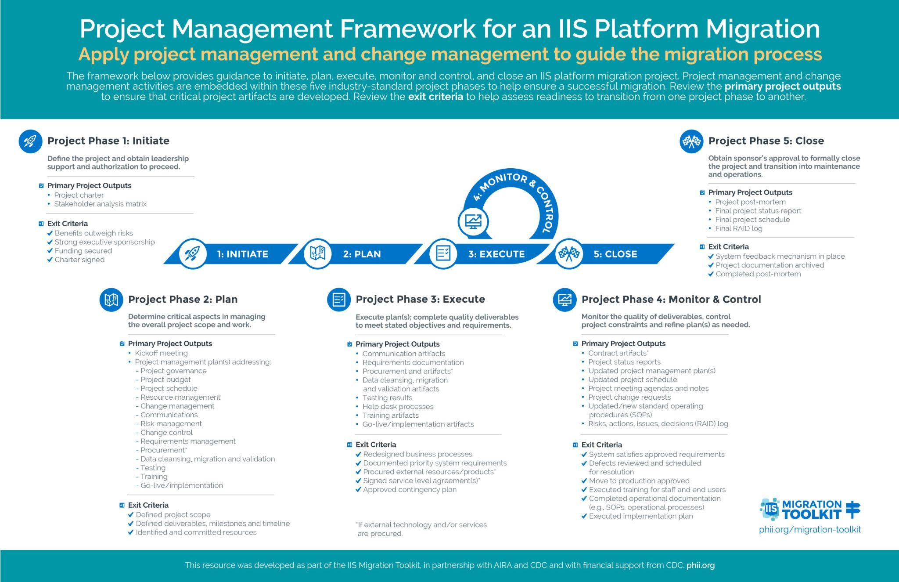

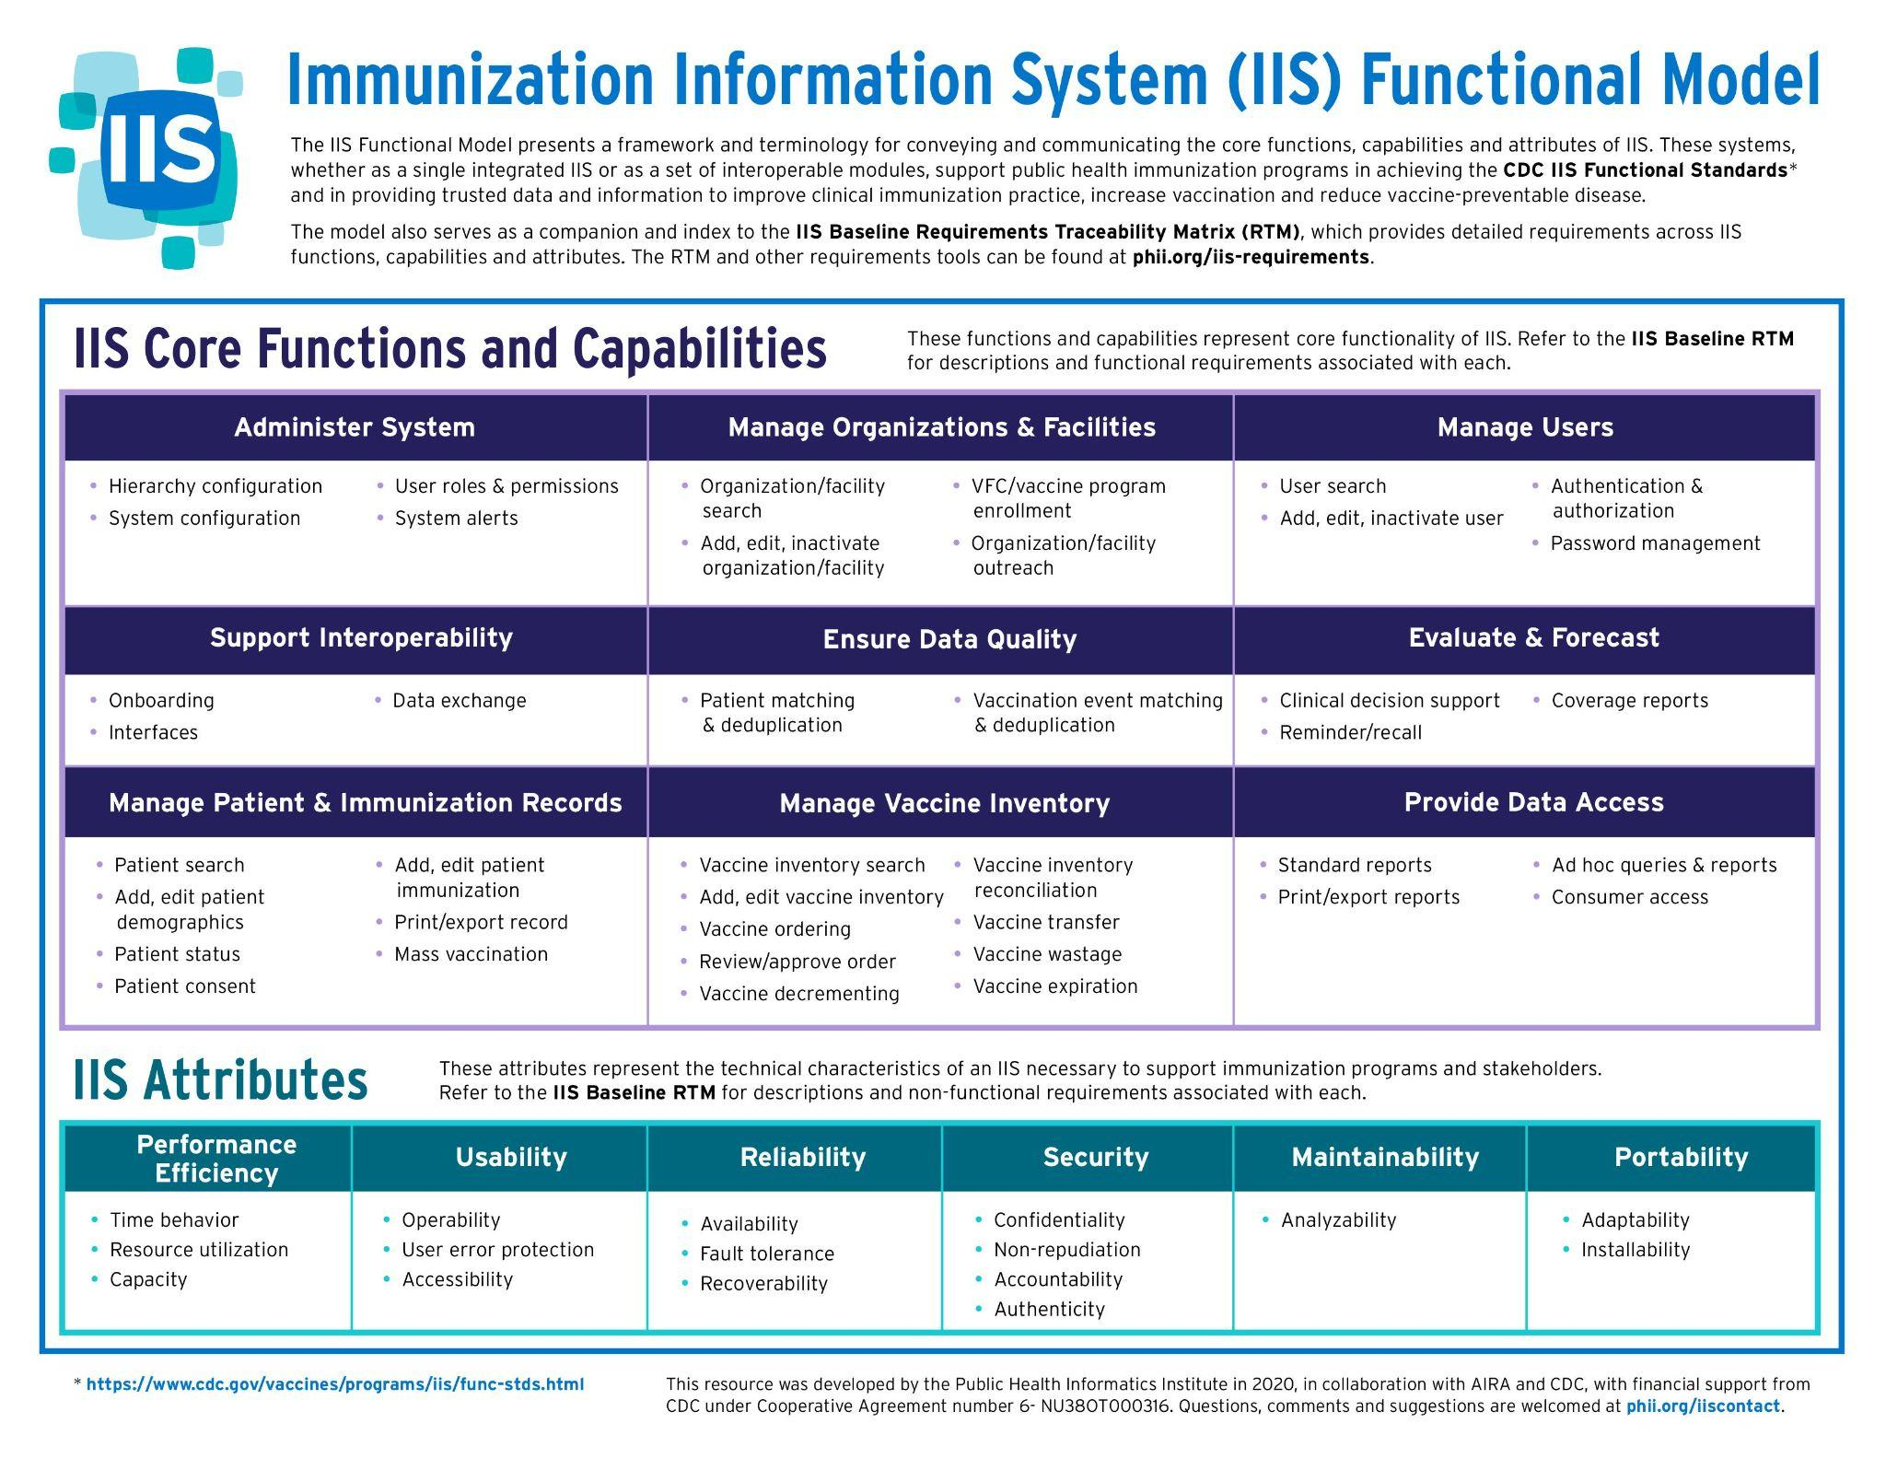
Appendix C: IIS Functional Model
