Sample Business Analyst Role Description
Review sample responsibilities and knowledge, skills and abilities of a business analyst
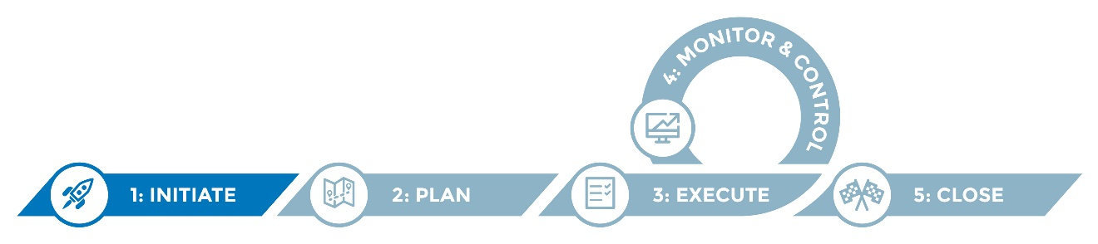

This sample role description identifies typical duties and responsibilities of a business analyst and indicates sample knowledge, skills and abilities of a person fulfilling this role. A business analyst can help a program understand and resolve challenges by gathering, documenting and analyzing needs and requirements.

Business analysts can be particularly helpful with large-scale projects such as an IIS platform migration, facilitating requirements gathering and documentation, business process redesign, and working closely with the vendor/IT on testing and implementing new requirements and revised workflows.

Instructions
- Review the sample content and refine it to suit your program and jurisdiction needs.
- Copy and/or re-use the content provided in a job description and/or statement of work.

Helpful hints
- While the sample role description speaks to a need for a business analyst in regard to an IIS platform migration, business analyst support for smaller-scale projects and program operations can also be beneficial.
- A business analyst may be available through your central IT.

Business analyst role description

Overview
Project and/or program overview: The Department of Public Health Immunization Program is replacing its current immunization information system (IIS) with a new technology platform. An IIS is a highly sophisticated statewide web-based system that consolidates immunization information from healthcare providers, hospitals, local health departments and others in order to prevent disease outbreaks, identify populations at risk of disease, and manage public-funded vaccine supplies.
A business analyst (BA) is needed to effectively manage the integration of process and technology in meeting the program needs for this IIS replacement. The BA will be responsible for creating, maintaining and coordinating project documentation, including current and future state process workflows and business requirements documents (BRDs). The IIS BA will be responsible for ensuring the timely input, review and approval of deliverables from the state’s perspective to successfully implement the new IIS. The IIS BA will assist in the testing and training of the new platform to ensure processes are well defined, communicated and successfully executed.
The BA will work under the supervision of the project manager, and in close collaboration with the program and vendor project teams.

Major duties and responsibilities
The BA is responsible for the coordination and completion of the programmatic deliverables associated with the replacement of the IIS system, and to ensure the functional and technical requirements for the new IIS are documented and approved to meet the needs of the immunization program and its stakeholders. Responsibilities of the BA will include, but are not limited to:
- Analyze policies and processes to understand impact on workflow.
- Document the “as-is” processes and workflows using process flows and other tools.
- Document the “to be” business processes using business process reengineering tools.
- Establish and maintain a standard operating procedure (SOP) inventory log and assist in the development of new and revised procedures.
- Work with stakeholders to elicit and document their business, functional and technical requirements, maintaining appropriate audit trails for those requirements.
- Facilitate workshops to elicit and prioritize requirements. Resolve and document conflicting requirements.
- Conduct assessments to compare available solutions in the marketplace to specified requirements and develop recommendations.
- Develop business cases and feasibility studies.
- Analyze complex data and provide meaningful interpretations of the results in the form of reports, graphs and other documents.
- In conjunction with the technical team, analyze, recommend and communicate proposed solutions.
- Work with internal IT staff to ensure that applications developed meet the needs and expectations of the immunization program and other stakeholders.
- Assist in testing including, but not limited to, user acceptance (development and execution of scripts) and regression testing.
- Contribute toward the development and delivery of appropriate training.
- Assist in project scope management.
- Support project management activities (status reporting, risk and issue mitigation, etc.).

Knowledge, skills and abilities
Proposed candidates should have a minimum of five years of business analysis experience across a variety of public health, healthcare and government agency settings. Experience working in or with immunization programs or with an IIS is strongly preferred. Specific qualifications include:
- Bachelor’s degree, Bachelor of Computer Science or International Institute of Business Analysis qualification.
- Proven experience in a business analyst role and in business analysis methods/techniques for all phases of application development including, requirements analysis, design and development, testing, and maintenance of reports.
- Strong oral and written communication and interpersonal skills.
- Ability to manage and document functional/non-functional requirements, test plans, test scripts and reports.
- Strong stakeholder management skills and experience in requirements collection, development and execution of successful workshops, and meeting facilitation.
- Strong requirements management experience (process) and proficiency in the use of requirements gathering, documentation and prioritization tools.
- Strong analytical skills, including ability to analyze data sources and design appropriate data presentation for diverse users.
- Experience in enterprise system implementation in the public sector that includes business process redesign preferred.
- Proficient in process workflow tools.
- High level awareness of a variety of IT software development methodologies and tools.
- Management, coaching or mentoring experience preferred.
- Working knowledge of healthcare industry and system applications preferred.
- Quality assessment and recommendations of project artifacts (e.g., use cases).
- Skill in developing and tracking project targets and metrics.

