Project Status Report Template
Document and report out project progress and status
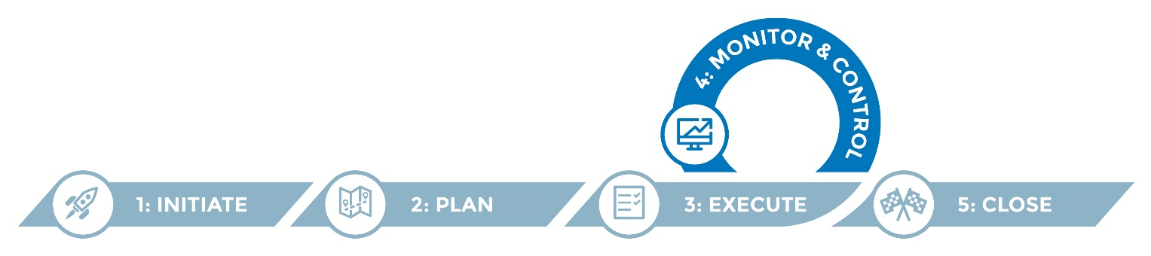
The project status report is a critical part of effective project communications to update the project team, sponsors and key stakeholders. The project status report is used to monitor and control project progress, or serve as a snapshot of where the project stands. It is typically developed by the project manager on a regular basis and can be customized by audience or stakeholder.

Instructions
- Review the template and refine it to suit your project needs.
- Determine how frequently the progress report will be completed and identify stakeholders who will receive the report.
- You can use the Project Charter and Project Plan to fill in objectives and activities you will report on.
- Complete the progress report for the given period, weekly or monthly.
- Distribute and post to the project repository.

Helpful hints
- Bolded text (as used above) indicates that the resource referenced is available elsewhere in the IIS Migration Toolkit.
- Use bold green, yellow and red color-coding to highlight project status. (See end of document for project status color key.)
- If communicating about the report via email, include a high-level summary in the body of the email message as well as the attachment/link to the complete report.

<Project Name> Status Report

Project Start Date: <Start date> Progress Report Period: <Start date - End date>
Project goal(s):

Project objectives | Overall project status
1.  2.  3.  4. | <% complete>  [As indicated in Project Plan]
Comments
<Information about the overall status of the project for this reporting period. Elaborate on the color-coded overall status above.>

Objective 1: <Objective> |  | Status: <% Complete>
Activities: |  | Outputs:
Activities completed/progressed during the reporting period
Activities planned for the next reporting period
Anticipated barriers, if any
Items needing discussion/escalation, if any

Objective 2: <Objective> |  | Status: <% Complete>
Activities: |  | Outputs:
Activities completed/progressed during the reporting period
Activities planned for the next reporting period
Anticipated barriers, if any
Items needing discussion/escalation, if any

Objective 3: <Objective> |  | Status: <% Complete>
Activities: |  | Outputs:
Activities completed/progressed during the reporting period
Activities planned for the next reporting period
Anticipated barriers, if any
Items needing discussion/escalation, if any

Objective 4: <Objective> |  | Status: <% Complete>
Activities: |  | Outputs:
Activities completed/progressed during the reporting period
Activities planned for the next reporting period
Anticipated barriers, if any
Items needing discussion/escalation, if any

Project status color key
Project status | Description
 | Everything is going well with the project.
 | There are potential issues with the project that need attention.
 | There are serious issues with the project that will cause delays or overrun the budget.

