Project Post-Mortem Template
Capture project feedback and learnings
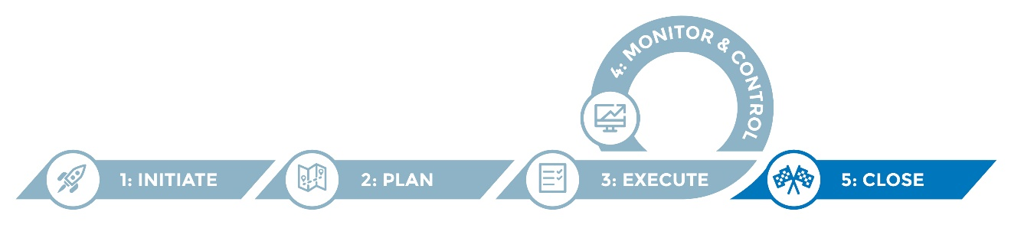

A project post-mortem, or project closeout, is conducted at the end of the project in order for the project team to review their work and collect lessons learned. The project outcomes and lessons learned should be archived and serve as institutional knowledge for future projects.

The post-mortem can be facilitated by the project manager or another unbiased person to solicit candid feedback from project team members and key stakeholders, if appropriate. The post-mortem can be a facilitated group session or individual interviews to solicit candid feedback from all participants. Typically, the project sponsor, project manager, project core team members and other key project stakeholders are involved in the post-mortem.

It is recommended that the post-mortem be conducted soon after the project is complete in order for project knowledge to remain “fresh” in the minds of the project team.

Instructions
- Modify the template to suit your needs.
- Identify a facilitator for your project post-mortem.
- Schedule a post-mortem as part of the project closeout.
- Prepare participants by letting them know in advance that a post mortem will be conducted and the objective—to solicit their candid perspective on what went well during the project and what could be improved for future projects.
- Use the template to record notes from the meeting and capture summary conclusions and actionable takeaways.
- Communicate post-mortem findings to the project team and project sponsor.
- Ensure completed notes are archived and accessible for future reference.
- Follow up on actionable takeaways such as policies/procedures to refine, etc.

Helpful hints
- Create a meeting agenda for the post-mortem to convey the meeting objectives and expectations. Send the agenda out to the participants prior to the meeting.
- Lessons learned from project post-mortems should be incorporated in upcoming projects.
- Boxes marked “note to author” (indicated with a lightbulb icon) are intended to serve as guidance and offer prompts as you populate the template, and should be deleted before the document is finalized.

Project post-mortem
Date/time
Location
Facilitator
Participants

Objective(s)
Note to author: Sample objectives are provided below for your reference and example, but should be removed if they are not applicable.

- Document learnings to be applied for future operations/projects.
- Gather information in order to create a final post-mortem report including what went well, challenges involved, lessons learned, recommended future actions, and information that will be helpful to future projects and teams.

Review of topics and questions
Topic/question | Notes
1. Project goals and objectives
  - How did the project turn out?
  - Were your goals and objectives as defined within the project charter met?
  - Are stakeholders satisfied with the results?
2. Stakeholder engagement, communication
        - Did all project team members (internal and external) have easy access to project materials, including planning documents, the project schedule and project progress reports?
        - Were external stakeholders adequately engaged and informed throughout the process?
3. Change management
              - Were change management strategies in place to ease stakeholders through the transition?
        - Were change management strategies in place to ease stakeholders through the transition?
4. Project management and planning
              - Was the project scope well defined?
  - Was the project schedule realistic with sufficient time built in for timely completion of all project activities?
  - Did the project engage the appropriate and sufficient staff/resources with the right skillsets?
  - Were project authority and accountability well defined and transparent?
  - Were the project team meetings well-structured and well-organized?
  - Were there gaps in project planning?
5. Project execution, monitor and control
- Were plans executed as anticipated?
- Were business processes analyzed and redesigned?
- Were requirements sufficiently and clearly documented and prioritized?
- Did the procurement process go smoothly (if applicable)?
- Does the system satisfy approved requirements?
- Were system defects reviewed and resolved appropriately?
- Was training for staff and end users sufficient?
- Was operational documentation (e.g., standard operating procedures) updated?
6. Project successes and lessons learned
- What worked especially well and why was that the case?
- What can be improved for better outcomes in future projects?
- What items are outstanding and/or what items from this post-mortem require follow-up action?
- Any additional thoughts?

Summary conclusions

Action items
Action item | Owner | Notes

