Project Charter Template
Define project parameters and outputs and authorize project kickoff
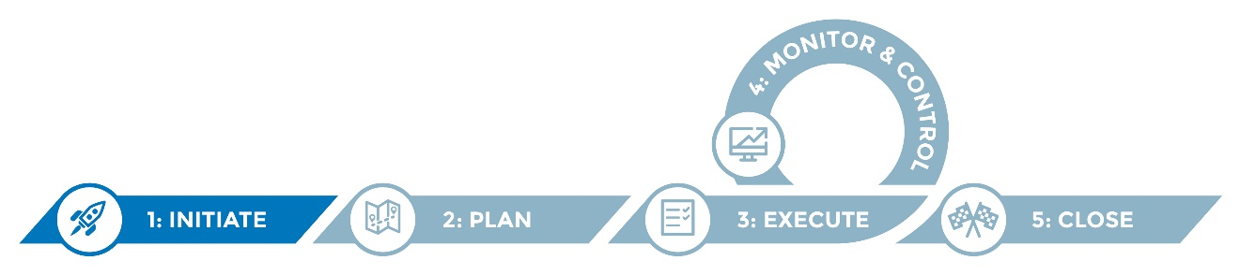

A well-written charter establishes a clear, compelling and shared vision for a new project, i.e., an initiative designed to achieve a particular goal during a specific time period. The charter defines how your agency/organization and one or more project partners will work together in agreed-upon ways to achieve the stated outcome(s), using defined methods and producing a defined deliverable(s). Ideally, once a project charter is signed, it remains an unchanging, foundational agreement among the partners. For this reason, charters benefit from being crystal clear and concise.

Charters should include everything that is important for the partners/signatories to agree upon and abide by but little more, since extraneous narrative takes attention off what is most important and may delay consensus.

Instructions
A key purpose of the chartering process is to stimulate thorough discussion and decision making with project partners. The chartering process of discussing alternatives and coming to consensus is actually more important than the actual approval of the charter document.
Once a charter is approved, the project manager/coordinator is authorized to kick off the plan phase of the project.

Helpful hints
This project charter template is intended to serve as a starting point and should be modified to suit your needs.
- Boxes marked “note to author” (indicated with a lightbulb icon) are intended to serve as guidance as you move through the template, and should be deleted before the document is finalized.
- You may want to integrate the RASCI Template into your project charter as you define roles and responsibilities.
- Bolded text (as used above) indicates that the resource referenced is available elsewhere in the IIS Migration Toolkit.
- Activities within the project charter should be kept in broad terms to prevent the need for amendments.

Project charter
Document version no.
Date

Project information
Project name
Project timeframe
Project lead
Project sponsor
Project partners

1.0 Project overview

1.1 Purpose and value
- What, in one to two sentences, is the intent of this project? What will be different and better?
- Why are the partners undertaking this project? Why is it important? Why is this the right time for this project?
- What is the strategic value to the health department? To the immunization program? To the partners?
 | Note to author: Think of this section as the “elevator speech.”

1.2 Background and description
- What historical or other information is necessary to understand the genesis, purpose, intended contributions and impact of this project? Who is funding the project? What are their expectations?
- What is the duration/timeframe of the project?

1.3 Scope
- What activities, content or processes are part of this project that are essential to achieving the objectives and milestones?
- What activities, intended outcomes or deliverables will not be part of this project? What would expand the project in ways that might jeopardize the stated objectives, timelines and/or budget?
Note to author: Identifying what is not in scope is often more important than what’s in.

1.4 Project objectives and milestones

Note to author: Objectives can be outcome objectives, which address the ends to be obtained, or process objectives, which address the means to get to the outcome objectives. Outcomes objectives stated in SMART format are preferred. Process steps are addressed in the “proposed activities” section. An objective
may at times sound like a deliverable. This is because the deliverable may be the physical result of the activities leading up to achieving the objective. For instance, an objective around defining system requirements can refer to both the process and end results of collective thinking, and the physical document that is used to disseminate those results. It may be helpful to outline the project phases under which each of these objectives falls (plan, execute, monitor and control or close).

1.4.1 Objective 1: <By MONTH DAY, YEAR, MEASURABLE ACTION will be achieved.>
Note to author: What are the incremental, achievable (within the project timeline), observable and measurable actions that will provide the means for attaining the goal?
Objective 1 activities

Note to author: What are the key activities for achieving each of the objectives? What are the major milestones for assessing progress, both in terms of both product(s)/deliverables and timeframe?
Objective 1 outputs

Note to author: What are the major milestones in terms of both product(s)/deliverables? What products or other artifacts are anticipated to be available because of this project? How are they intended to be used?

Objective 1 outcomes

Note to author: What is the intended outcome/impact of these objectives? Think of the goal as answering the questions: What will stakeholders do with the deliverable(s)? How will they benefit? Such outcomes likely won’t happen before the end of the project, so goals have a longer horizon than project timelines.
Also, the project may not be the only activity that contributes to achieving that goal. The objective goal does not have to be measurable, but should be fairly concrete and uniformly interpreted across the partners.

1.4.2 Objective 2: <By MONTH DAY, YEAR, MEASURABLE ACTION will be achieved.>
Objective 1 activities

Objective 1 outputs

Objective 1 outcomes

Note to author: Replicate the same process used for filling out objective one, and repeat for any subsequent objectives.

2.0 Project roles

2.1 Roles and responsibilities
Organization | Role name | Role description for the project | Name and title

Note to author: Who are the partners, and what are their roles in terms of contributions to the project? Who are other stakeholders and their respective roles during their project and/or in helping disseminate products?

3.0 Project reporting and communications

3.1 Coordination and communication goals

What are coordination and communication goals?

3.2 Methods of communication and coordination
- How will communication occur among the partners?
- Where will project artifacts and materials reside/be stored?
- How frequently will stakeholders meet, at least initially?
- How frequently will project updates be communicated, how will they be communicated, and to whom will they be communicated?

4.0 Additional project information

4.1 Project constraints
- What are limitations or restrictions to be aware of?

4.2 Assumptions
- What is being taken as a given (e.g., that all the partners will agree to work together, that partners agree with the project purpose and goal)?

4.3 Risks and risk mitigation
- What events or factors in the environment could undermine the project in terms of achieving the desired outcomes in the timeframe specified?

Identified risks and mitigation plans:
Risk description | Impact if realized (high, medium, low) | Probability of realization*  (high, medium, low) | Mitigation efforts and response

Note to author: Consider transferring these risks to a risks, actions, issues and decisions log (RAID Log) to facilitate reference and updates throughout the project.

5.0 Signatures
The signatories below approve this project charter, approve initiation of the project, and agree to adhere to and support the project as outlined in the charter.

____________________________________ ________________
Name, organization Date

____________________________________ _________________
Name, organization Date

____________________________________ ________________
Name, organization Date

Note to author: Not every project requires a signed charter. The key question is: Do we definitely need to know, before starting this project, whether we are in agreement on the project goals, objectives, scope and deliverables with internal and/or external partners that will be part of project governance and decision-
making? This may or may not include the funder.

