Learner Personas Worksheet
Create personas to inform training design and delivery
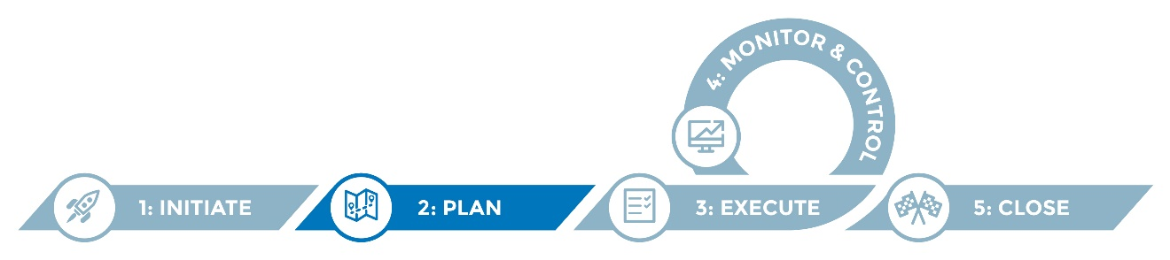

Learner personas are fictional characters developed to represent a particular user group. The development of personas promotes a user-centric perspective to inform training requirements and activities when a system change is planned.

Personas are based on first-hand knowledge of users and consist of a fictional name, relevant characteristics and goal(s) in relation to using a system. The goal is the benefit the user group wants to achieve or the problem the user group wants the system to solve. This information is conveyed in a corresponding user story, i.e., a brief statement that describes specific functionality required to achieve the users’ goals.

Instructions

Review the sample personas provided.

Modify and/or add to these examples to develop personas for your IIS users. Consider key users who will require training to be prepared for the system change.

Reference these personas in developing your training plan and training materials. Consider what each persona must be able to do in the new system to support their goals.

Helpful hints
- Refer to your Stakeholder Analysis Workbook to help identify potential personas.
- Consider consulting with real-life users to better understand and document their needs and enrich the learner personas.
- Use these personas to inform training action mapping using the Action Mapping Worksheet and the development of a training plan using the Training Plan Template.
- These user personas can also be leveraged to help define system requirements for various users and to inform communication planning.
- Bolded text (as used above) throughout the worksheet indicates that the resource referenced is available elsewhere in the IIS Migration Toolkit.

Learner Personas Worksheet
Note: Add rows as needed.

Name | Characteristics | Goals and action steps | User story
<Fictional name to represent a group of users> | <Descriptive characteristics related to this group of users (role, knowledge, experience, etc.)> | <Benefit the persona wants to achieve or problem the character wants to see solved by using the system. You may want to list the specific steps the persona needs to take to achieve these goals. Best practice: Write these goals in active tense.> | <Brief statement that describes specific functionality required to achieve the users’ goals, stated from the user perspective:  As a____________ , I need to____________so that ___________.>

Learner personas: samples
Note: The personas below are provided for illustrative purposes.
Name | Characteristics | Goals and action steps | User story
<Fictional name to represent a group of users> | <Descriptive characteristics related to this group of users (role, knowledge, experience, etc.)> | <Benefit the persona wants to achieve or problem the character wants to see solved by using the system. You may want to list the specific steps the persona needs to take to achieve these goals. Best practice: Write these goals in active tense.> | <Brief statement that describes specific functionality required to achieve the users’ goals, stated from the user perspective:  As a____________ , I need to____________so that ___________.>
Lynette | Clinic nurse -  new in role | Get up to speed on using the IIS.  - Log in to IIS.  - Find/create a patient  - Interpret patient immunization history, evaluation, and forecast.  - Run reports. | As a clinic nurse, I need to be directed to online training so I can easily and quickly get answers to my questions.
Mitch | School office administrator -in role 22 years | Monitor and report on school immunization requirements.  - Log in to IIS.  - Navigate the system.  - Search for students.  - Interpret immunization records.  - Create list(s).  - Run and interpret school report(s). | As a school administrator, I need to access the IIS so I can monitor and report on school immunization requirements.
Sally | Clinic vaccine coordinator- in role 15 years | Fulfill VFC requirements.  - Log in to IIS.  - Place a vaccine order.  - Manage and reconcile vaccine inventory.  - Complete and update provider profile. | As a clinic vaccine coordinator, I need to access the IIS so I can fulfill VFC requirements.
Camilla | Clinic nurse manager | Manage site and user access to the IIS.  - Log in to IIS.  - Navigate the system.  - Reset user passwords.  - Create new users.  - Edit user accounts. | As a nurse manager, I need to access the IIS so I can edit user accounts and train staff on using the IIS.
Sally | Immunization field consultant/ staff | Conduct outreach and support providers in using the IIS.  - Perform outreach.  - Conduct training. | As an immunization field staff member, I need to perform outreach and training so I can educate my providers on how to use the IIS system.
Rick | EHR vendor | Support a bi-directional interface.  - Securely connect to the IIS.  - Submit quality HL7 messages to the IIS.  - Format HL7 messages.  - Monitor the HL7 interface.  - Address quality concerns. | As an EHR vendor, I need to support a bi-directional interface so I can fulfill my responsibilities to my clients.

